**Experiment 1-2**

Question1. L is a list defined as L= [11, 12, 13, 14].

i. WAP to add 50 and 60 to L.

Code:

|  |
| --- |
| L = [11, 12, 13, 14]  L = L + [50, 60]  print(L) |

Output:

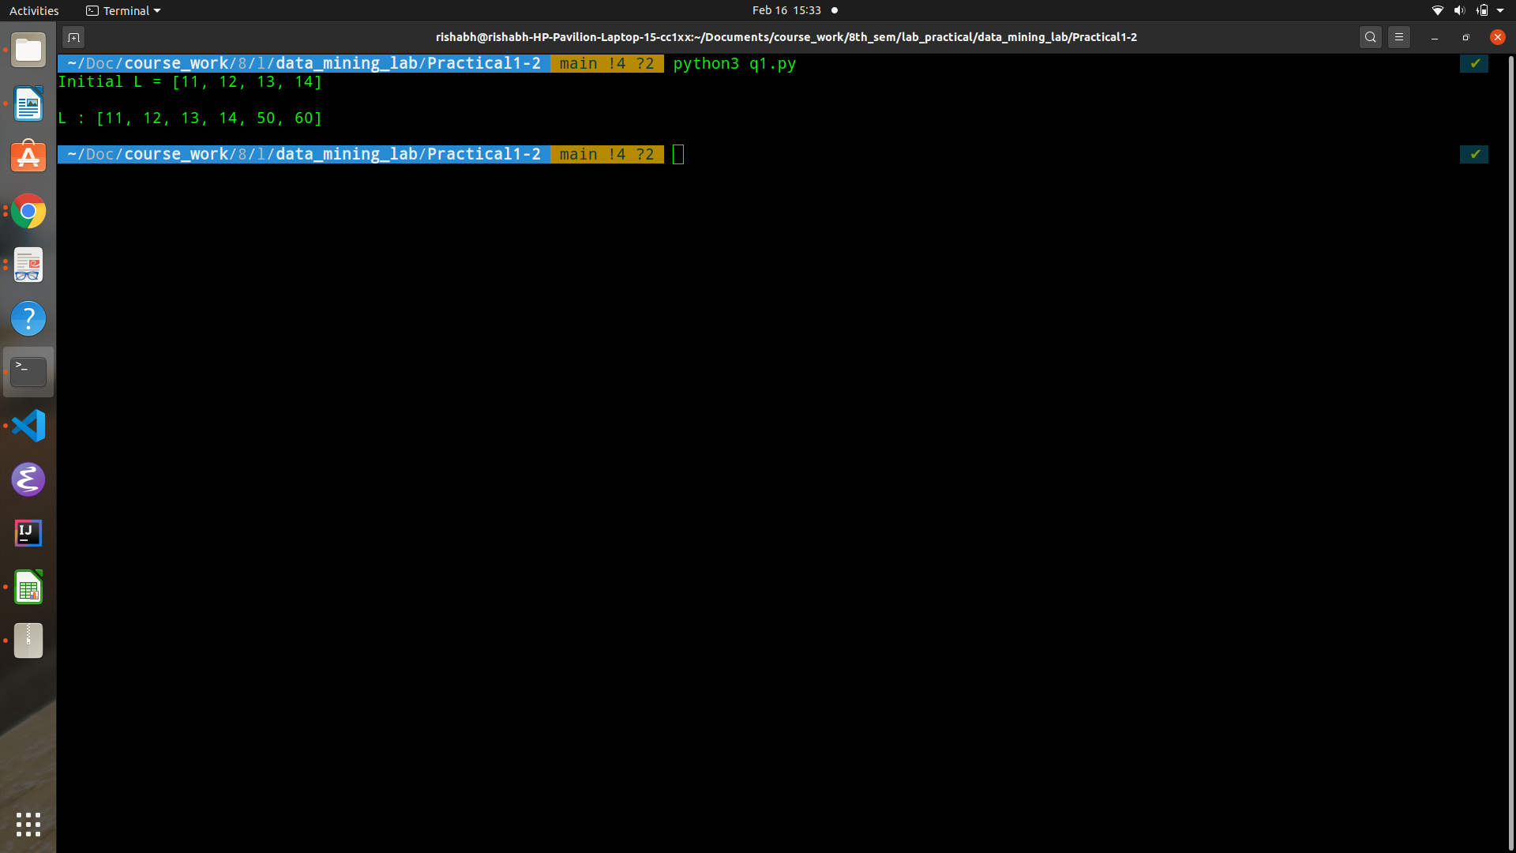

ii. WAP to remove 11 and 13from L.

Code:

|  |
| --- |
| remove_items = [11, 13]  L = [x for x in L if x not in remove_items]  print(L) |

Output:

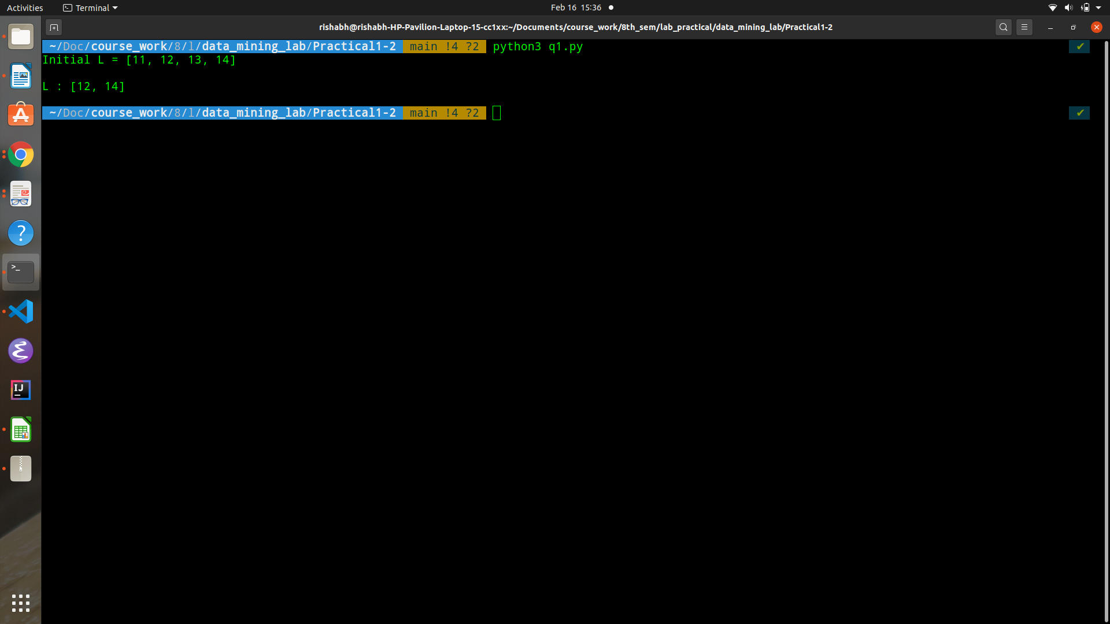

iii. WAP to sort L in ascending order.

Code:

|  |
| --- |
| L.sort()  print(L) |

Output:

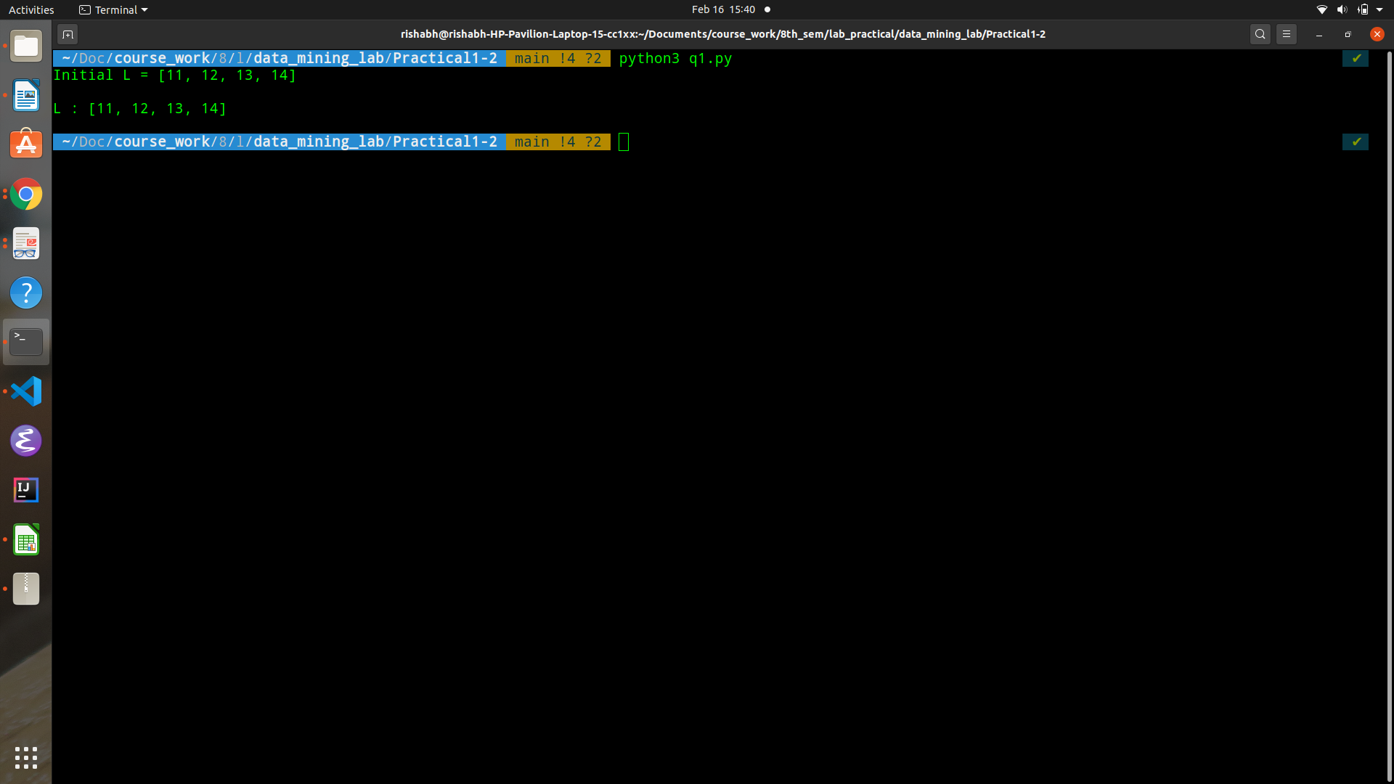

iv. WAP to sort L in descending order.

Code:

|  |
| --- |
| L.sort(reverse=True)  print(L) |

Output:

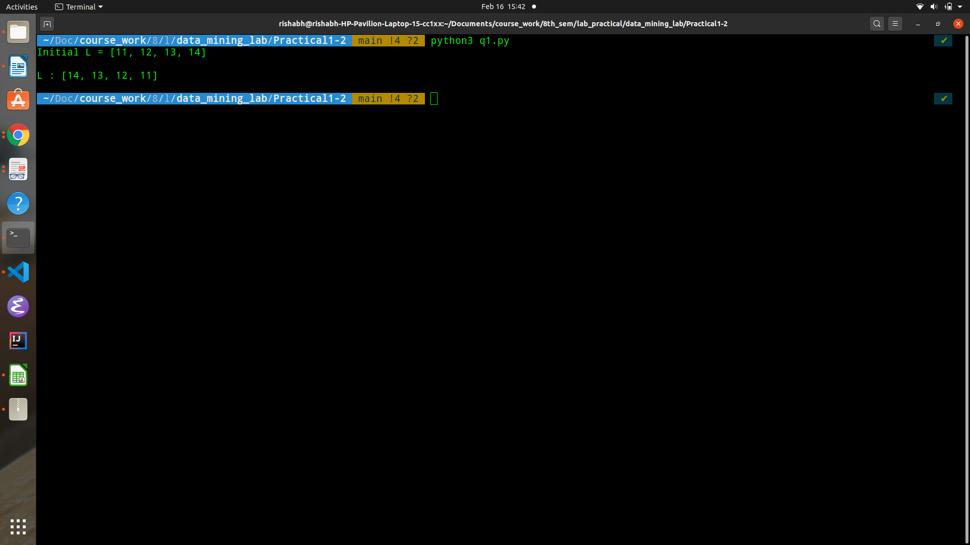

v. WAP to search for 13 in L.

Code:

|  |
| --- |
| def search(List, element):  return ( element in List)  print(f'IS 13 PRESENT IN L : {search(L, 13)}') |

Output:

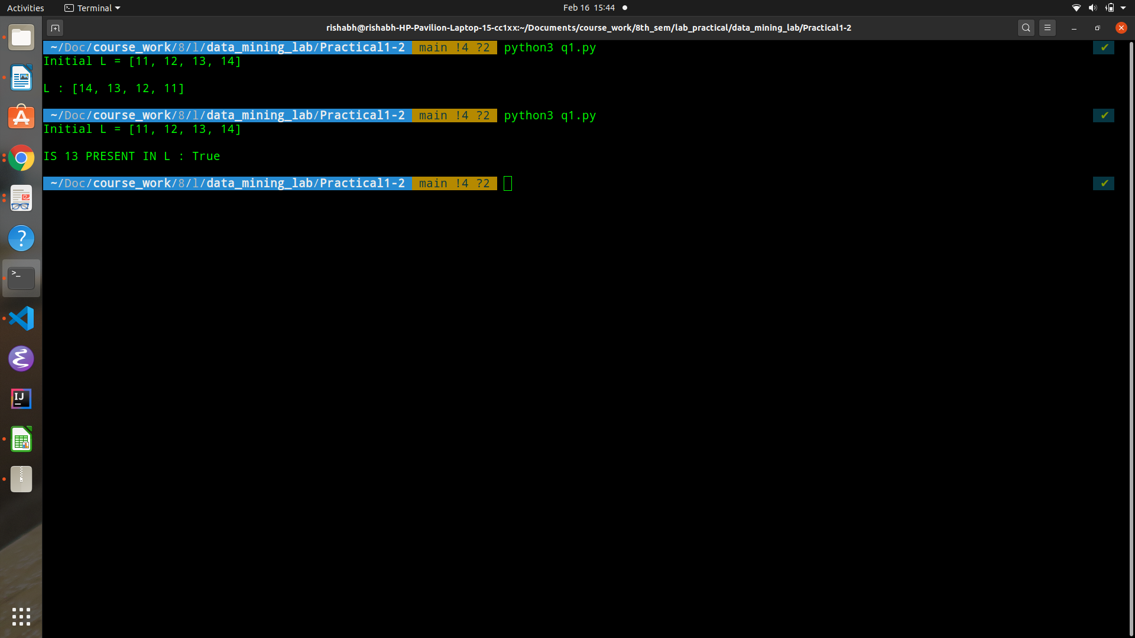

vi. WAP to count the number of elements present in L.

Code:

|  |
| --- |
| def count_elements(List):  return len(List)  print(f'NUMBER OF ELEMENTS IN L: {count_elements(L)}') |

Output:

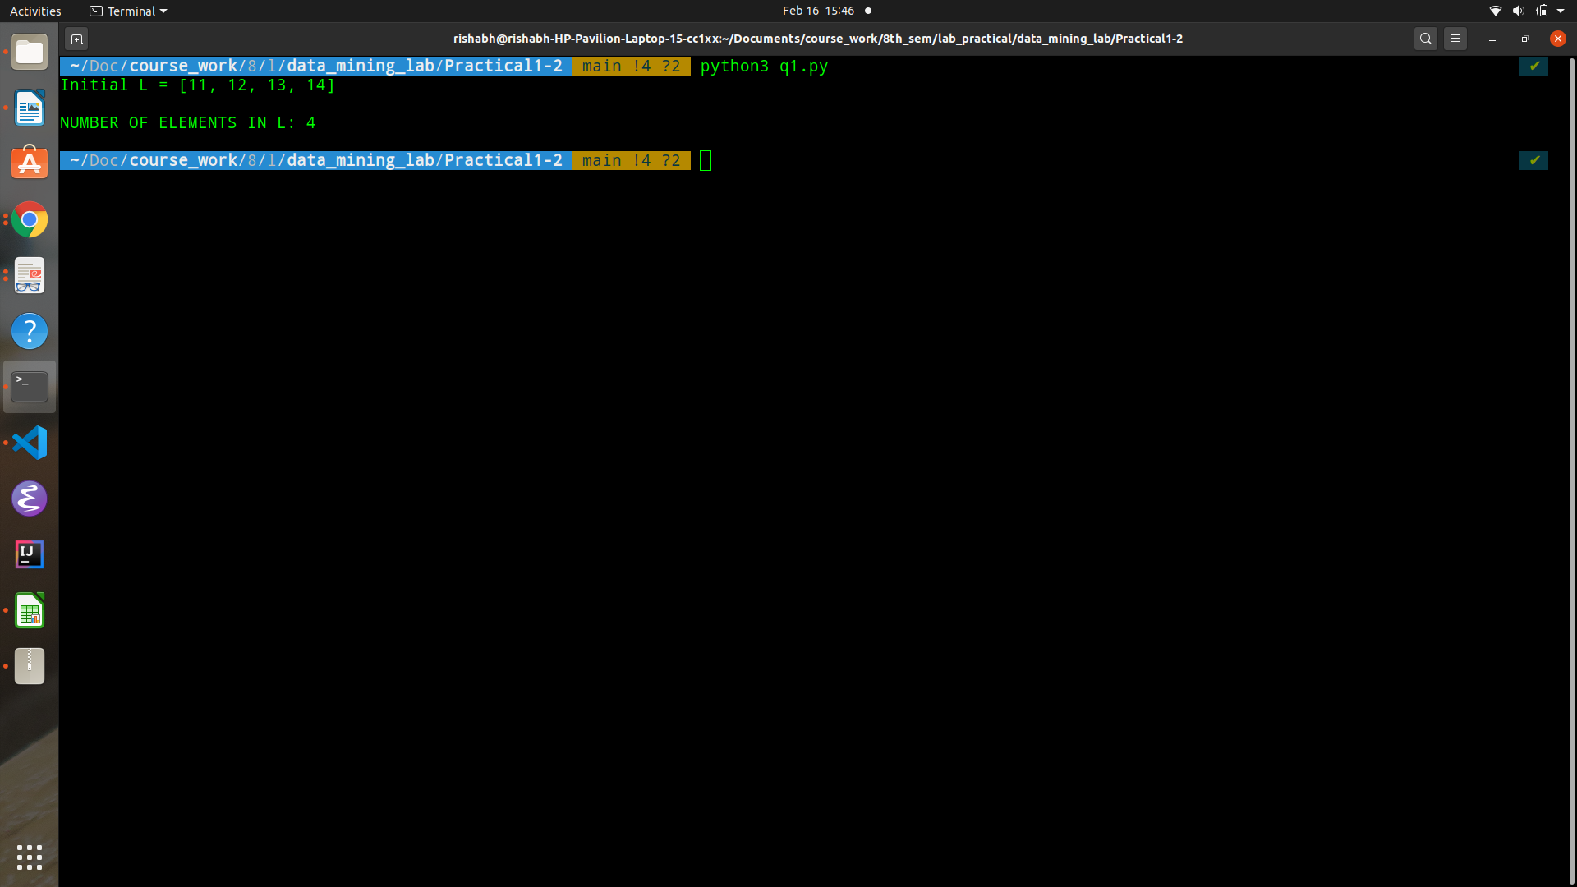

vii. WAP to sum all the elements in L.

Code:

|  |
| --- |
| sum_of_all_elements = sum(L)  print(sum_of_all_elements) |

Output:

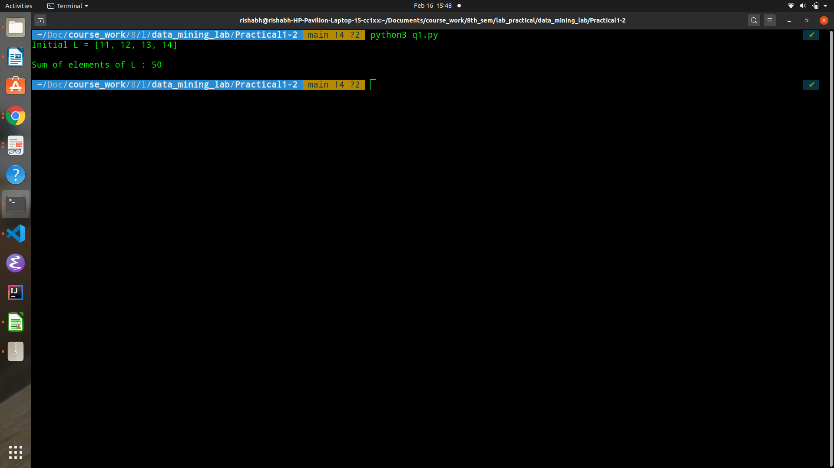

viii. WAP to sum all ODD numbers in L.

Code:

|  |
| --- |
| odd_elements = [element for element in L if (element % 2 != 0)]  sum_of_odd_elements = sum(odd_elements)  print(sum_of_odd_elements) |

Output:

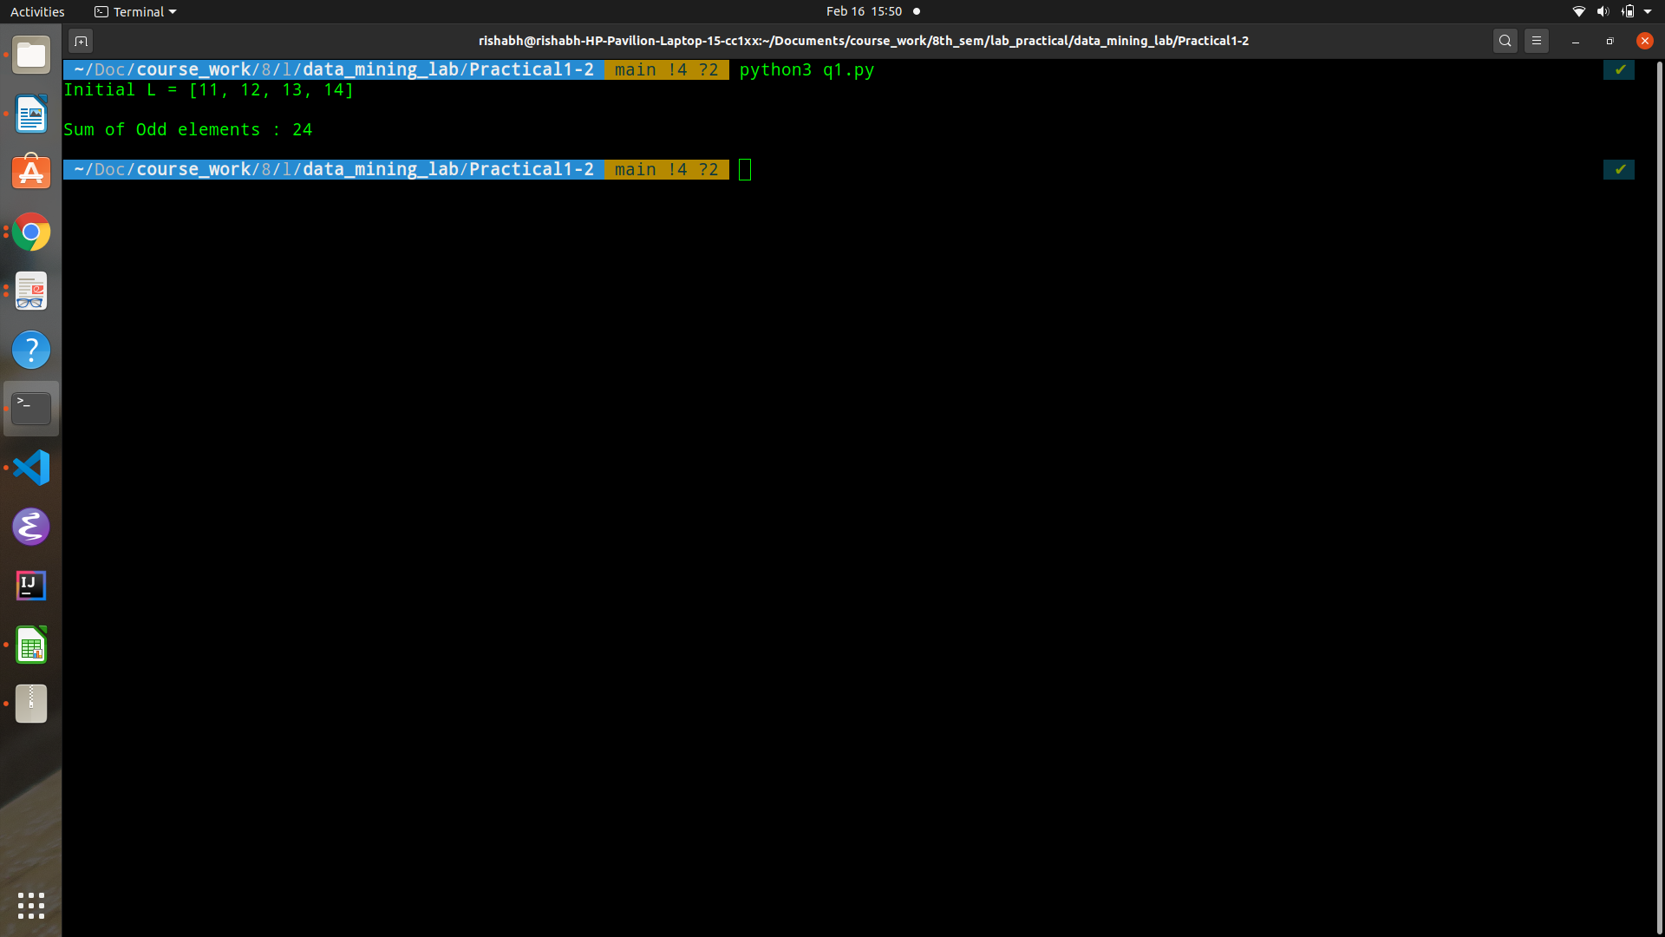

ix. WAP to sum all EVEN numbers in L.

Code:

|  |
| --- |
| even_elements = [element for element in L if (element % 2 == 0)]  sum_of_even_elements = sum(even_elements)  print(sum_of_even_elements) |

Output:

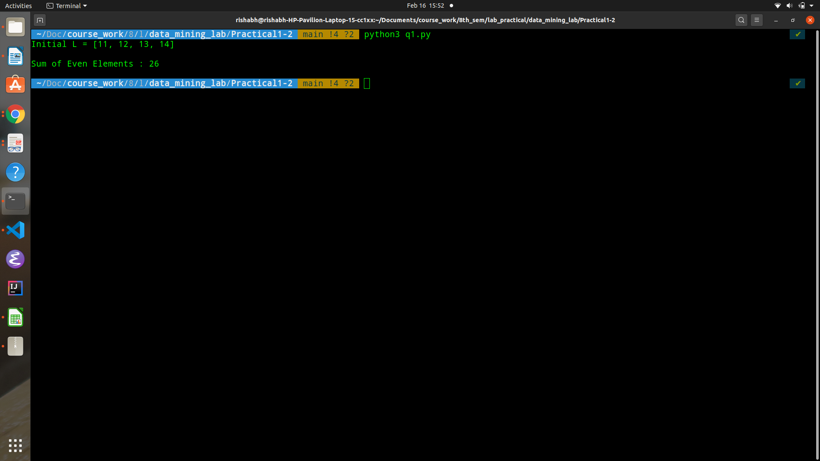

x. WAP to sum all PRIME numbers in L.

Code:

|  |
| --- |
| def is_prime(element):  if element < 2:  return False  i = 2  while i * i <= element:  if element % i == 0:  return False  i += 1  return True  prime_elements = [element for element in L if (is_prime[L])]  sum_of_prime_elements = sum(prime_elements)  print(sum_of_prime_elements) |

Output:

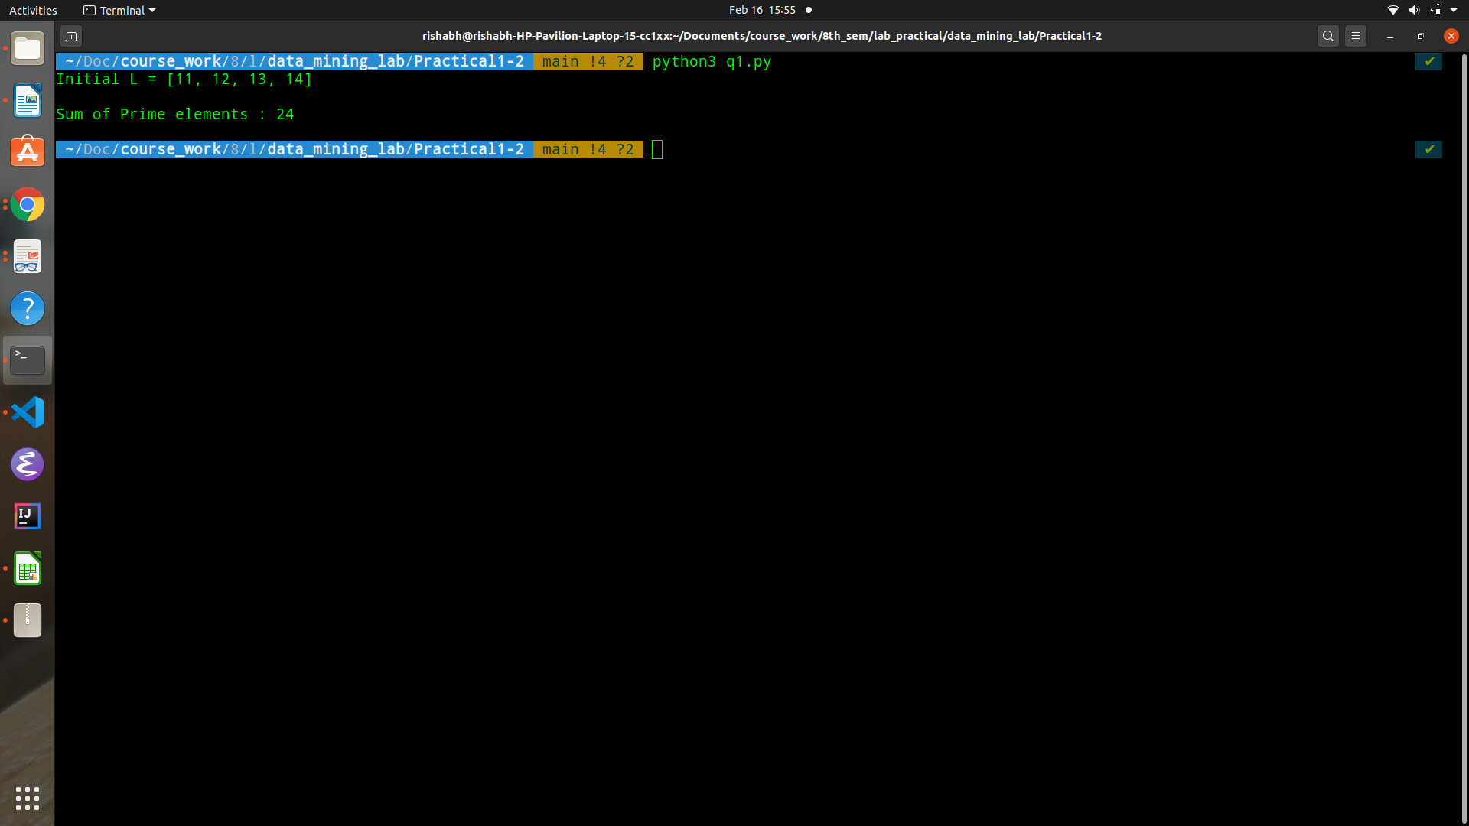

xi. WAP to clear all the elements in L.

Code:

|  |
| --- |
| print("CLEARED --L--")  L.clear()  print(L) |

Output:

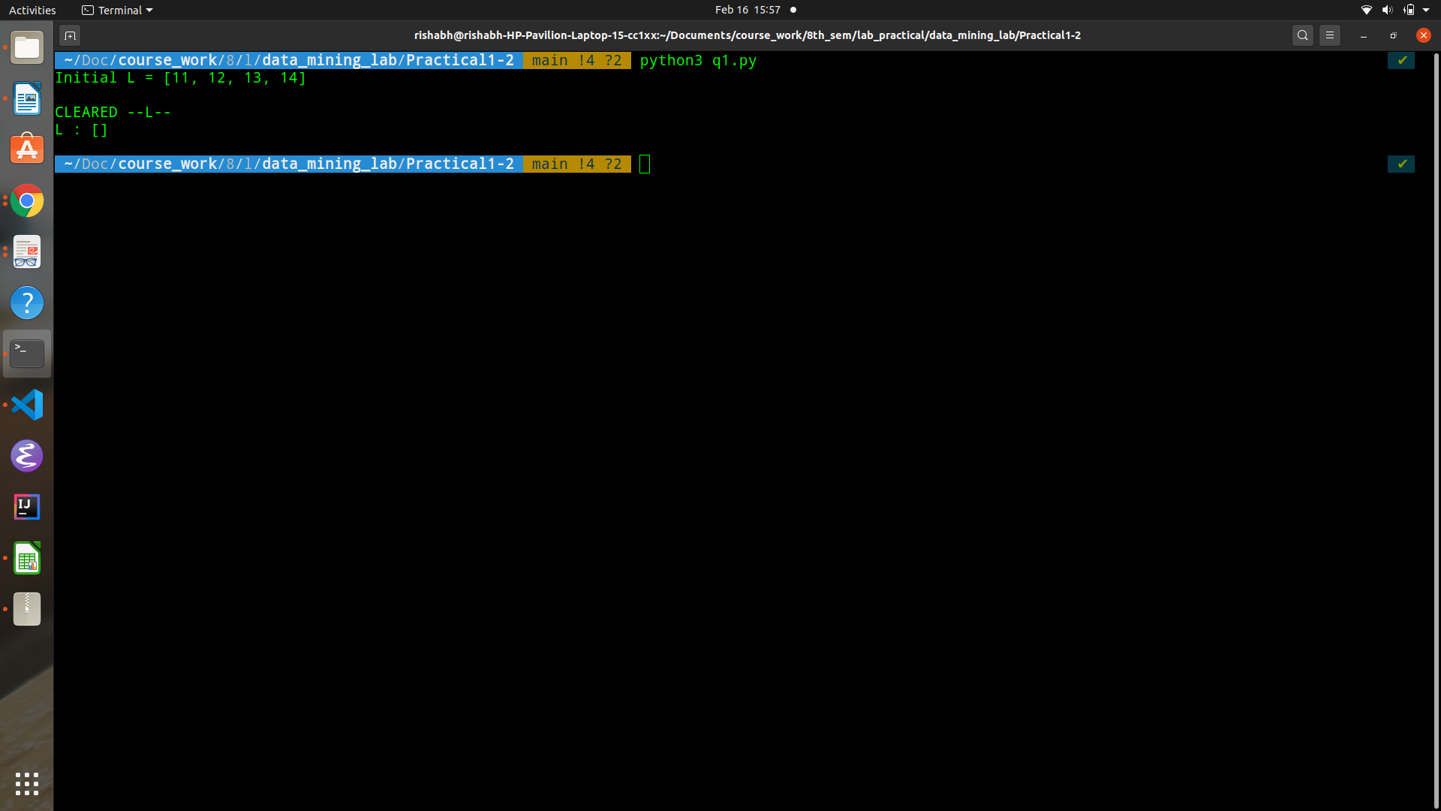

xii. WAP to delete L.

Code:

|  |
| --- |
| print("Deleting --L--")  del L  print(L) |

Output:

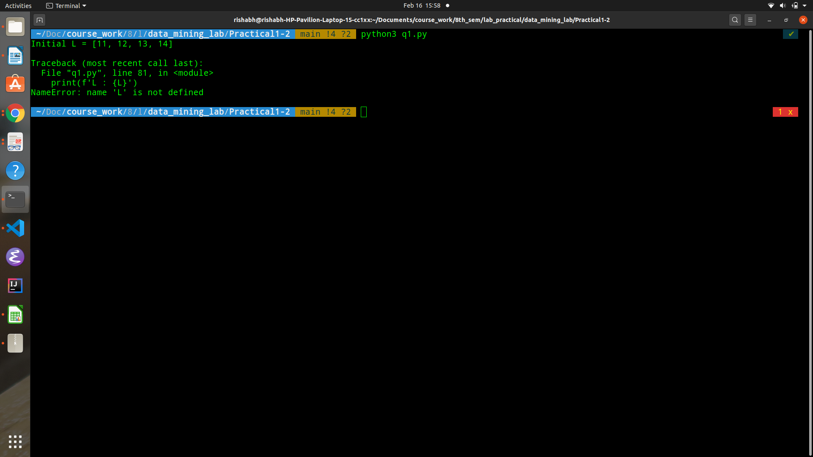

Q2. D is a dictionary defined as D= {1:5.6, 2:7.8, 3:6.6, 4:8.7, 5:7.7}.

|  |
| --- |
| D = {  1 : 5.6,  2 : 7.8,  3 : 6.6,  4 : 8.7,  5 : 7.7  } |

i. WAP to add new entry in D; key=8 and value is 8.8

Code:

|  |
| --- |
| D[8] = 8.8  print(D) |

Output:

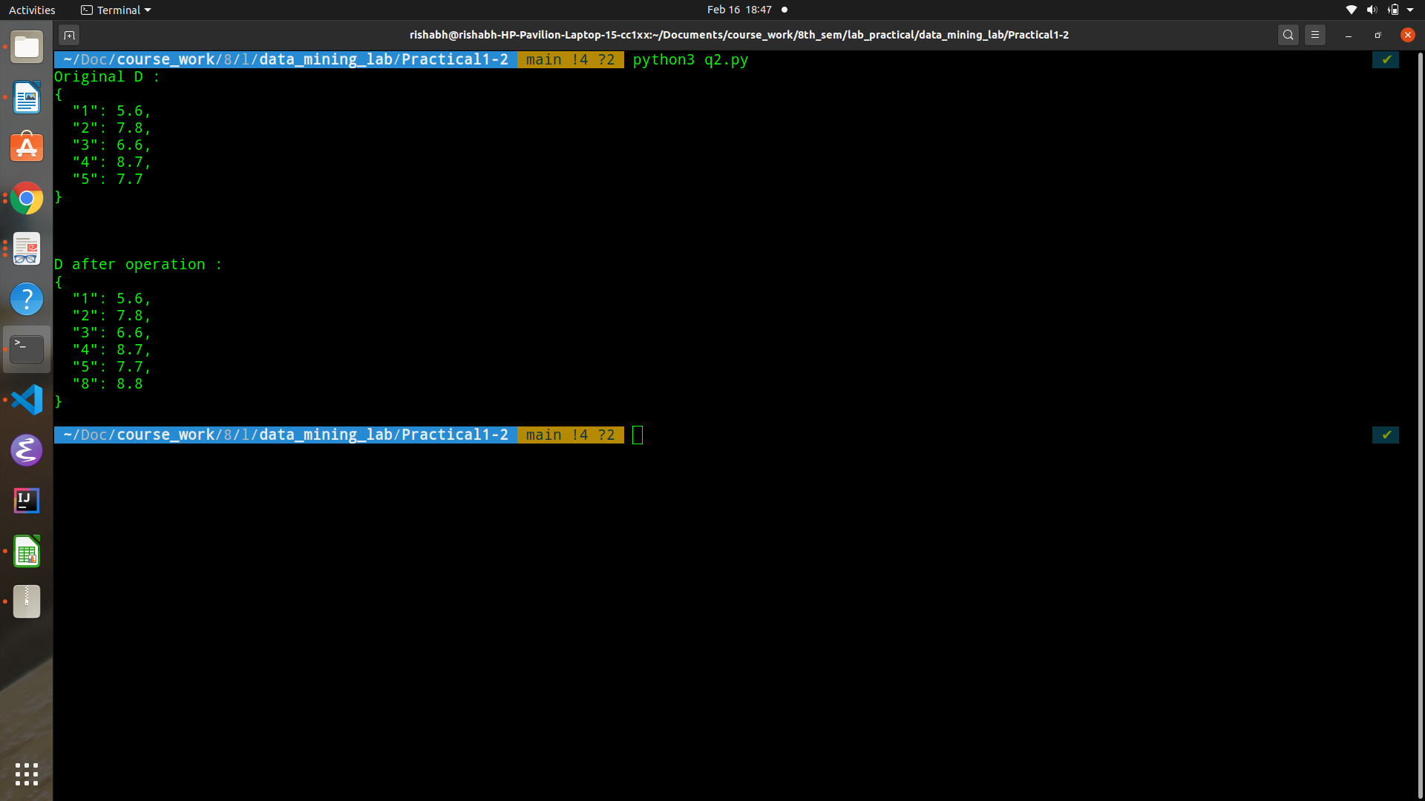

ii. WAP to remove key=2.

Code:

|  |
| --- |
| del D[2]  print(D) |

Output:

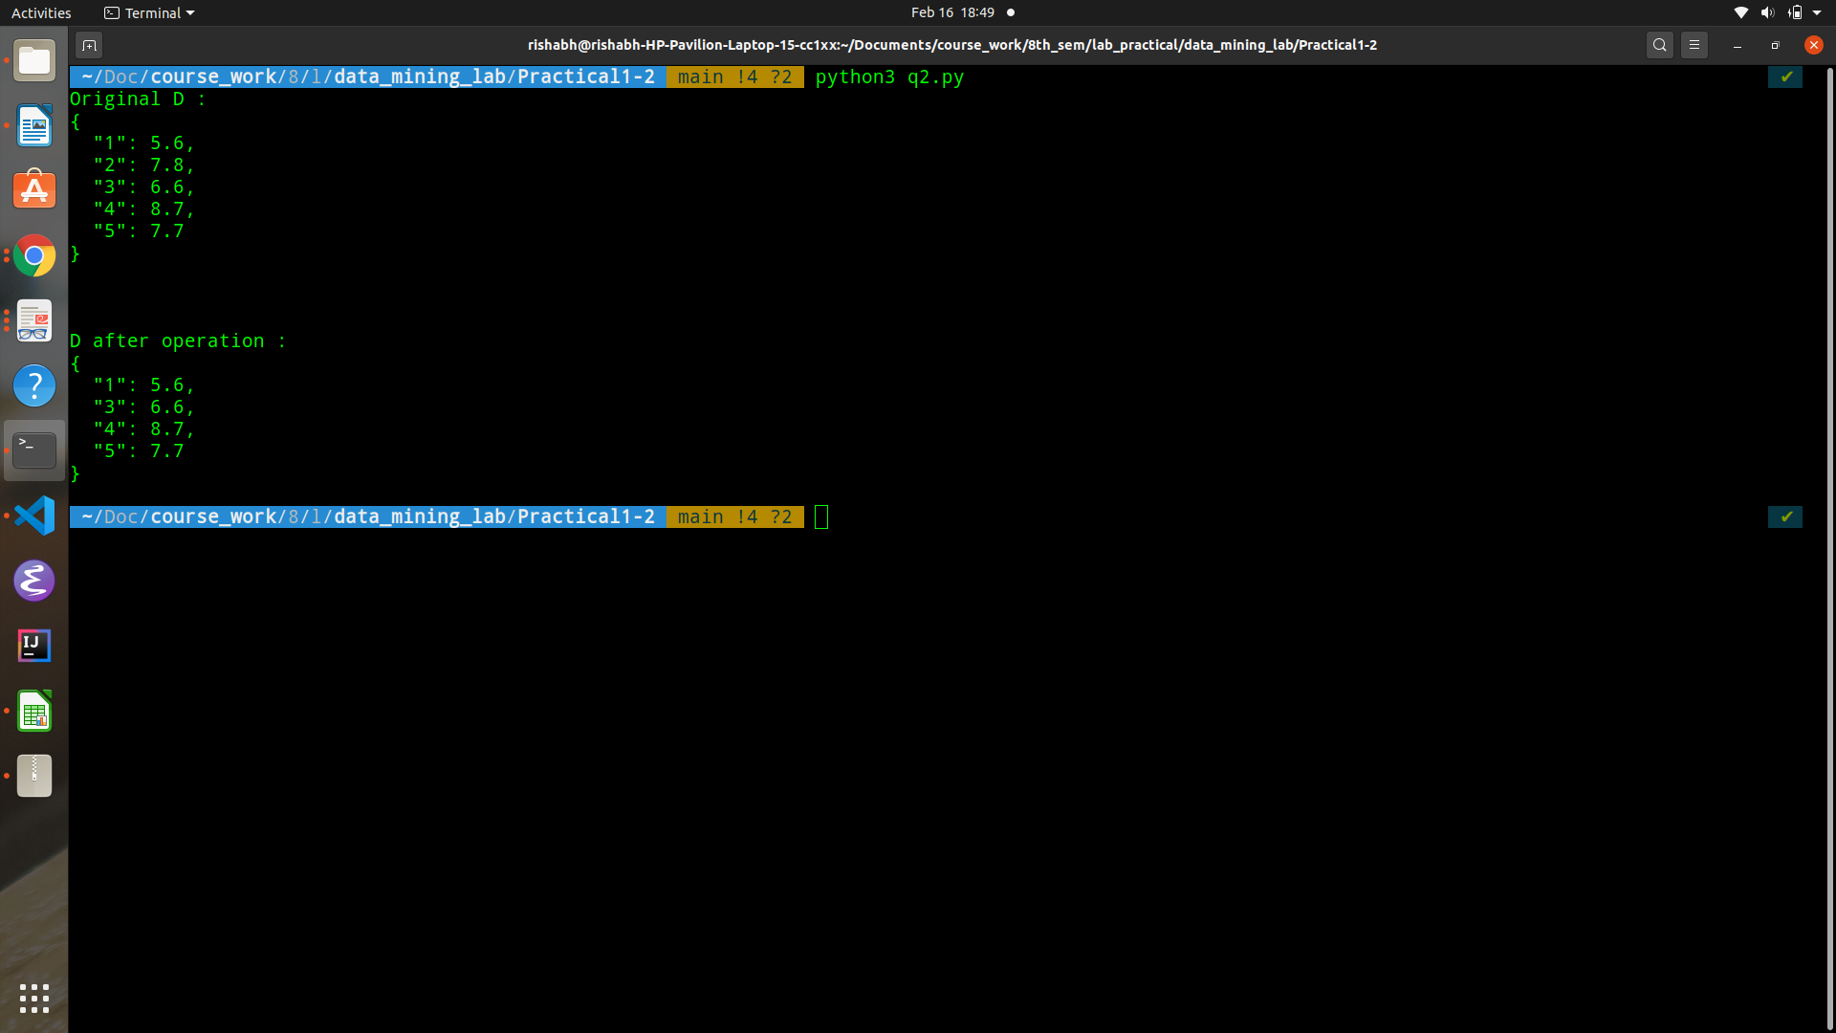

iii. WAP to check weather 6 key is present in D.

Code:

|  |
| --- |
| is_6_present = ( 6 in D)  print(is_6_present) |

Output:

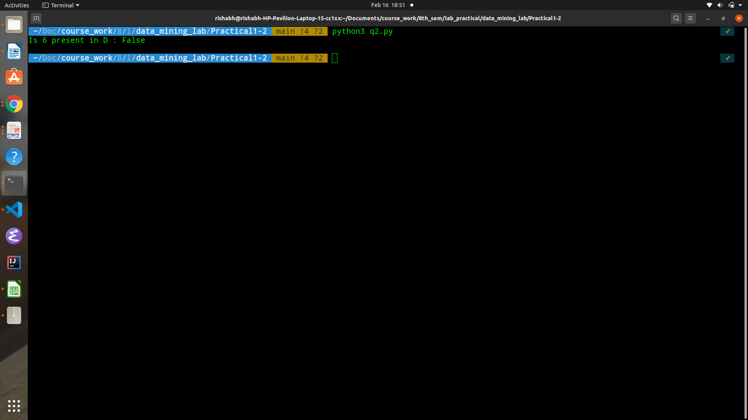

iv. WAP to count the number of elements present in D.

Code:

|  |
| --- |
| print(len(D)) |

Output:

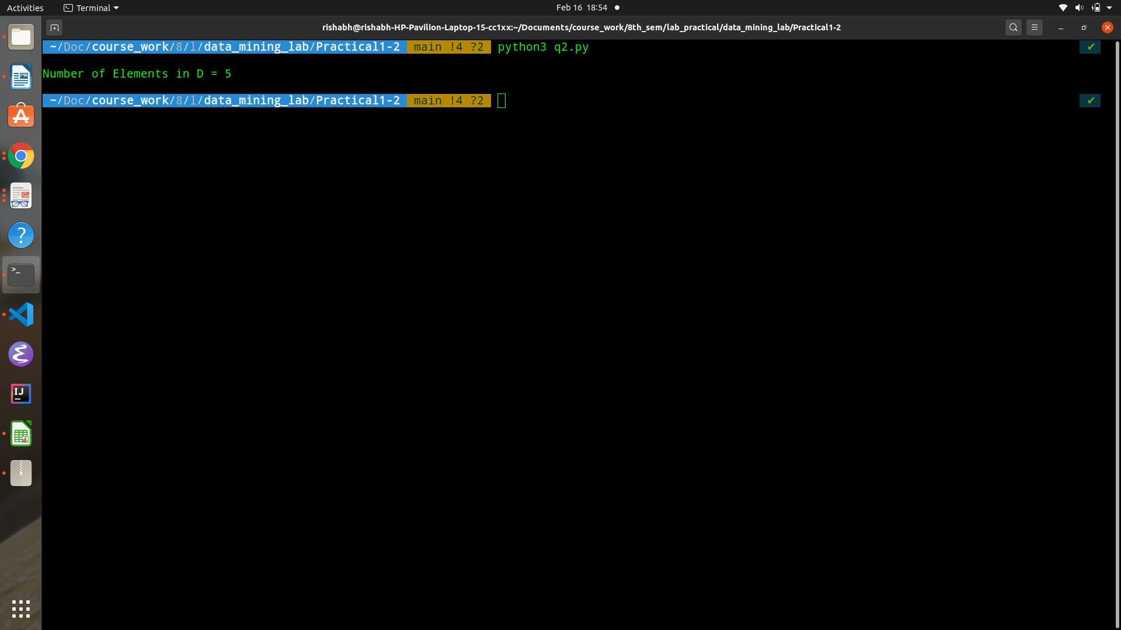

v. WAP to add all the values present D.

Code:

|  |
| --- |
| sum_values = sum(D.values())  print(sum_values) |

Output:

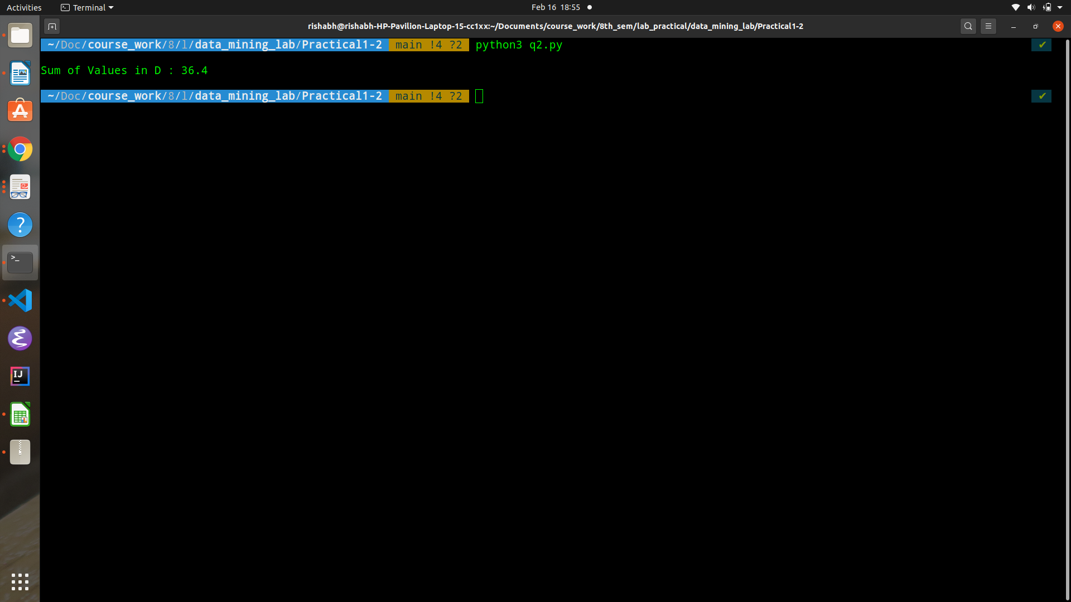

vi. WAP to update the value of 3 to 7.1.

Code:

|  |
| --- |
| D[3] = 7.1  print(D) |

Output:

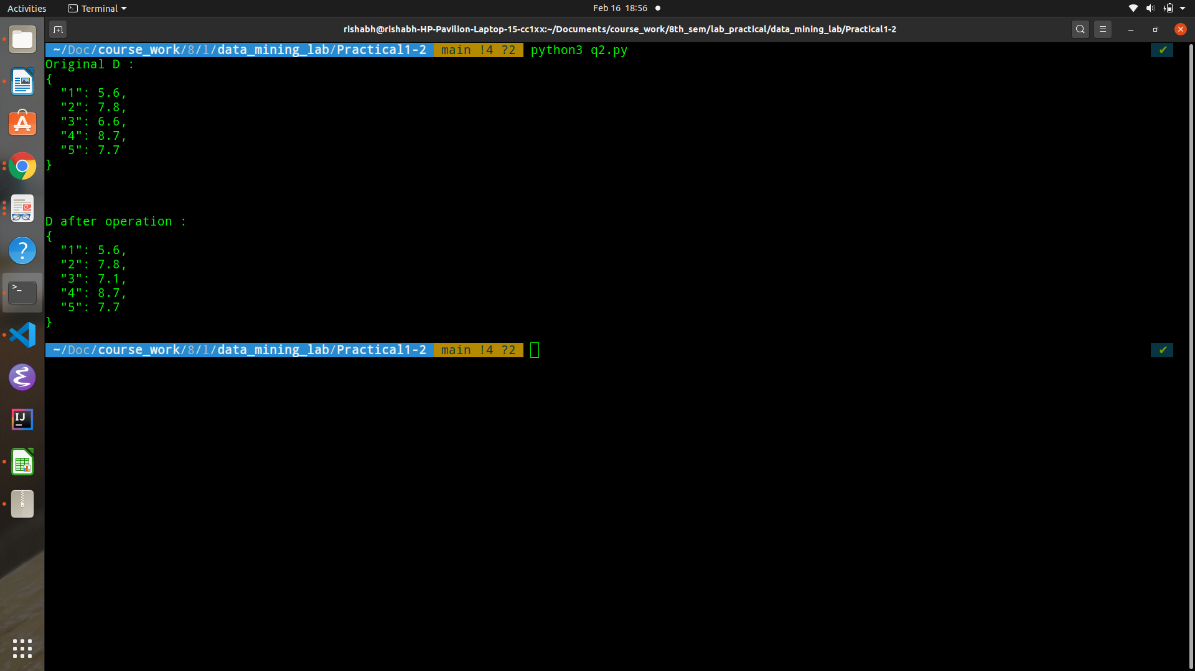

vii. WAP to clear the dictionary.

Code:

|  |
| --- |
| D.clear()  print(D) |

Output:

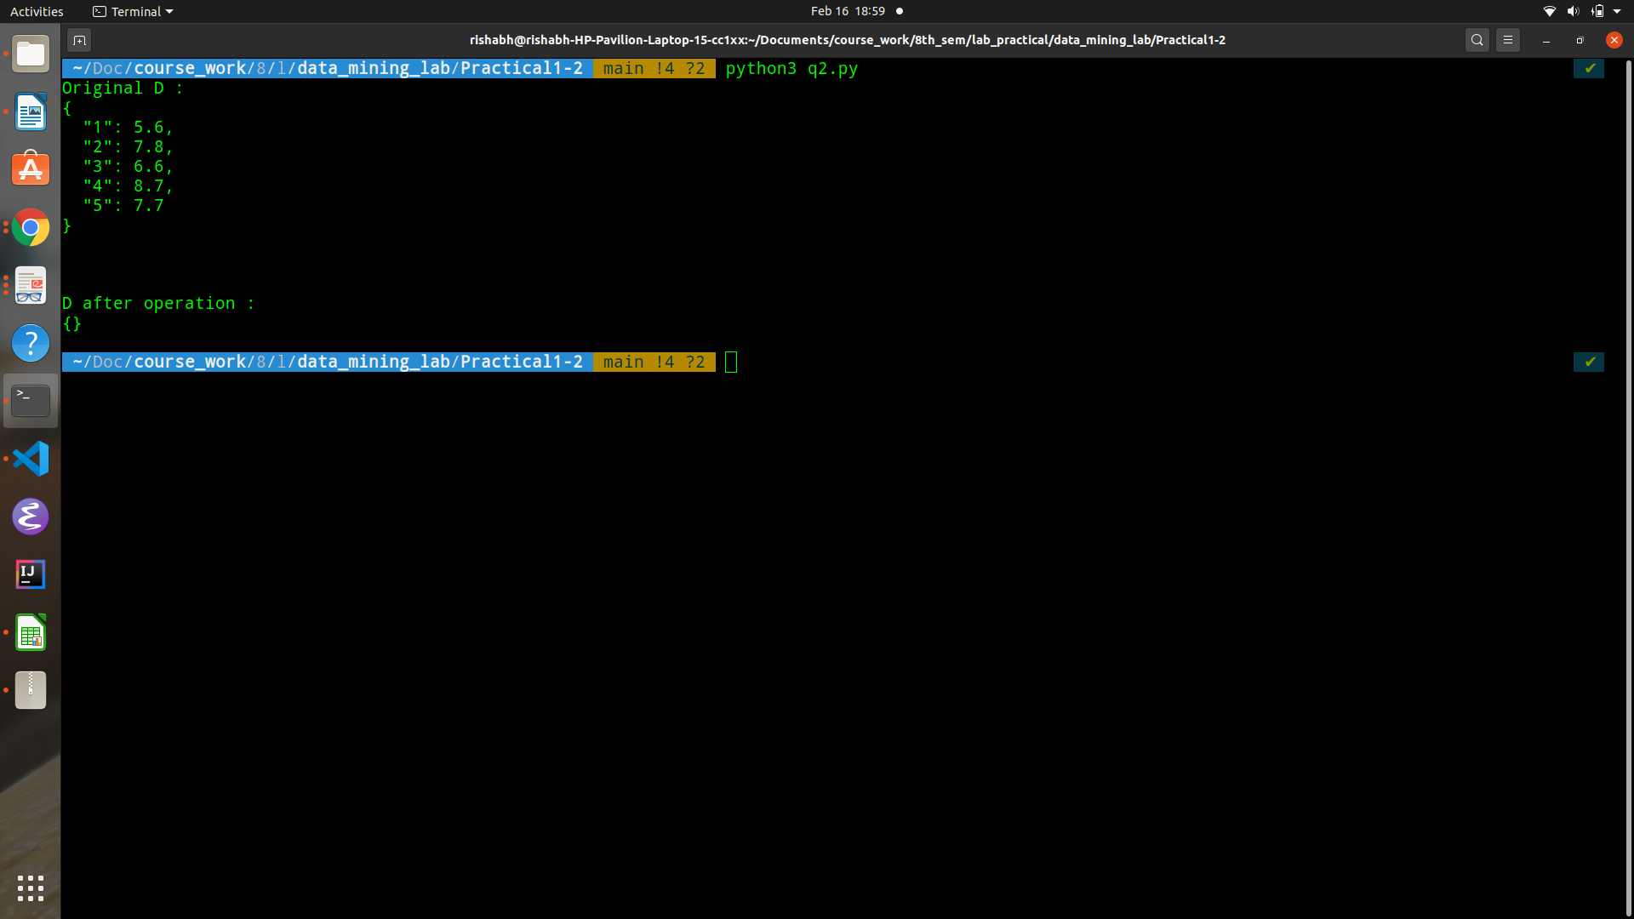

Q3. S1 is a set defined as S1= [10, 20, 30, 40, 50, 60].

S2 is a set defined as S2= [40, 50, 60, 70, 80, 90].

|  |
| --- |
| S1 = {10, 20, 30, 40, 50, 60}  S2 = {40, 50, 60, 70, 80, 90} |

i. WAP to add 55 and 66 in Set S1.

Code:

|  |
| --- |
| S1.add(55)  S1.add(66)  print(S1) |

Output:

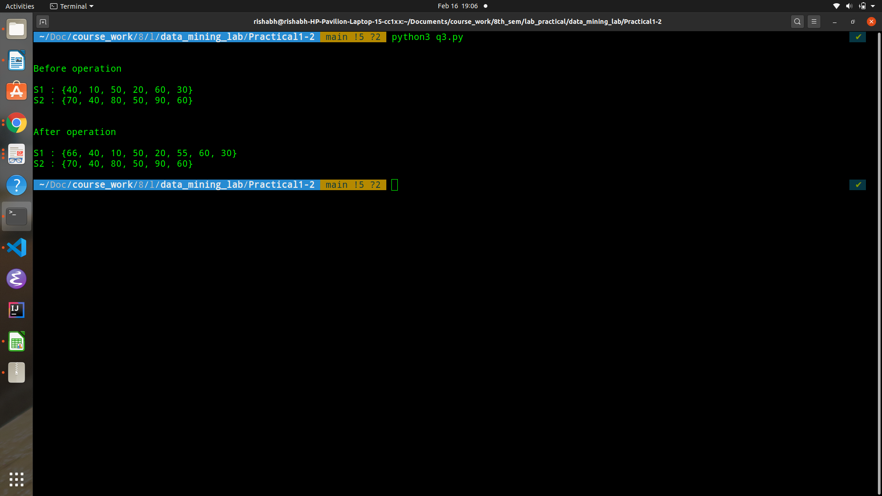

ii. WAP to remove 10 and 30 from Set S1.iii. WAP to check whether 40 is present in S1.

Code:

|  |
| --- |
| S1.remove(10)  S1.remove(30)  print(S1) |

Output:

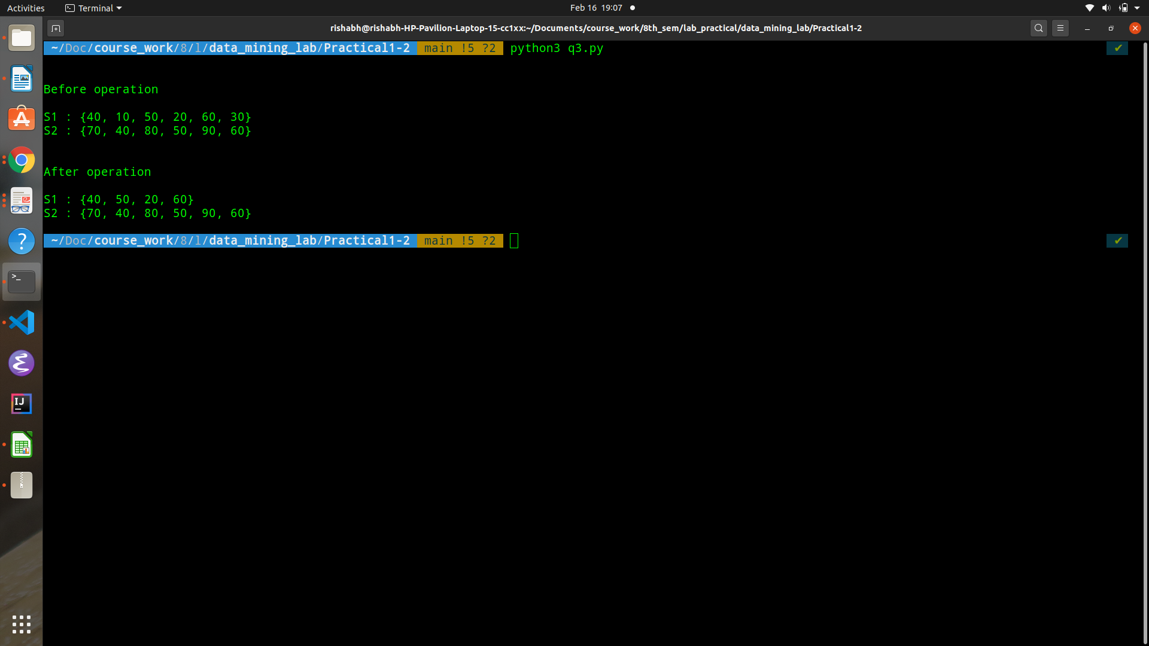

iv. WAP to find the union between S1 and S2.

Code:

|  |
| --- |
| print ( S1 | S2 ) |

Output:

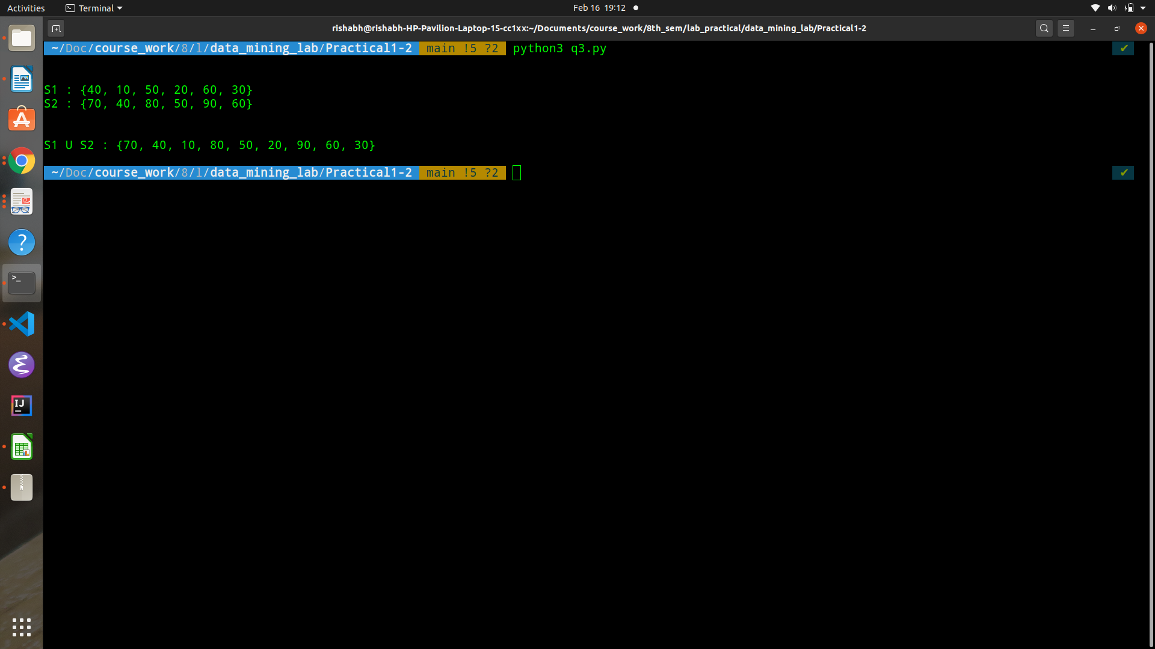

v. WAP to find the intersection between S1 and S2.

Code:

|  |
| --- |
| print ( S1 & S2 ) |

Output:

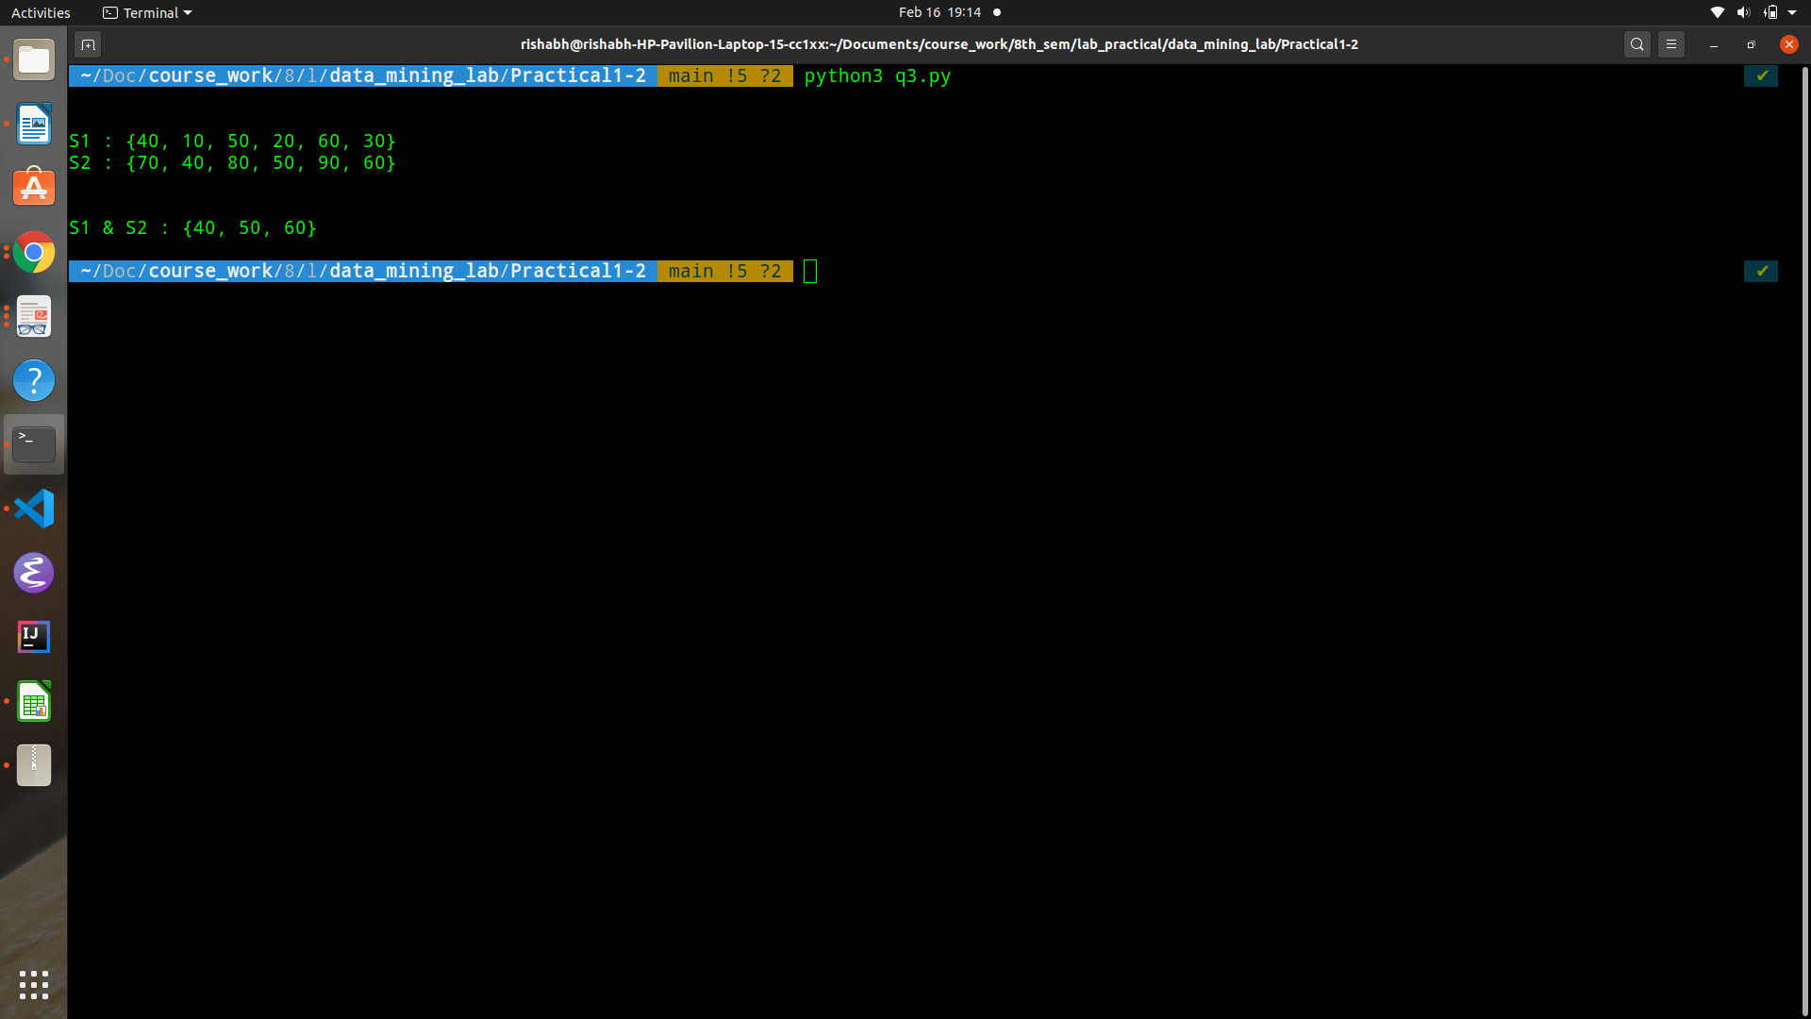

vi. WAP to find the S1 - S2.

Code:

|  |
| --- |
| print(S1 - S2) |

Output:

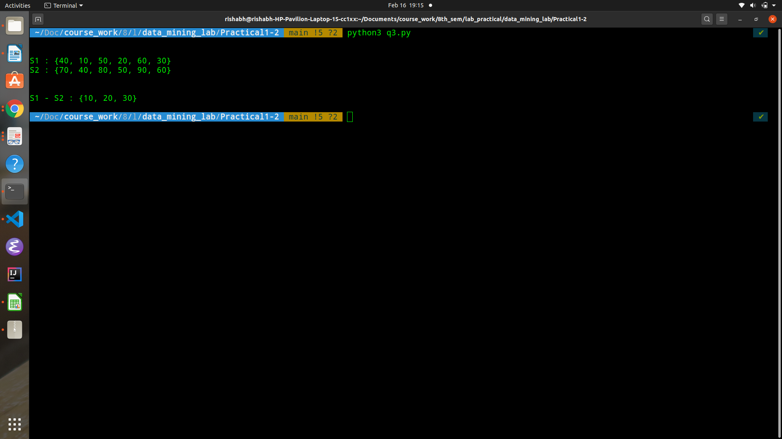

Q4. Write the following program.

i. WAP to print 100 random strings whose length between 6 and 8.

Code:

|  |
| --- |
| *######## generate 100 random strings with length 6 and 8 #####*  import string  import random  length_options = [6, 7, 8]  letters = string.ascii_letters  hundred_random_strings = []  # make random perms of letters  for i_str in range(0, 100):  random_len = random.choice(length_options)  random_string = ''.join(random.choice(letters) for i in  range(random_len))  hundred_random_strings.append(random_string)  print(len(hundred_random_strings))  print(hundred_random_strings) |

Output:

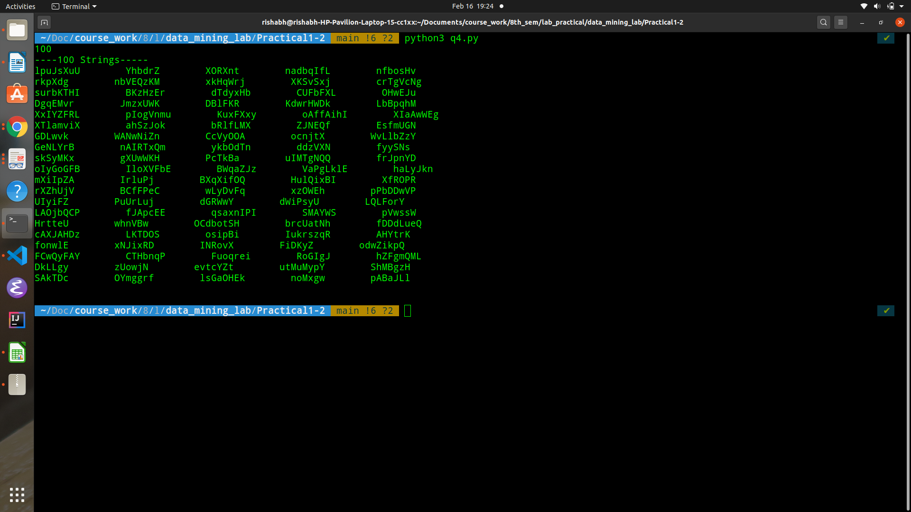

ii. WAP to print all prime numbers between 600 and 800.

Code:

|  |
| --- |
| is_prime = [1 for i in range(801)]  ###### 0 and 1 are not prime  is_prime[0] = is_prime[1] = 0  ####### use sieve  i_element = 2  while (i_element ** 2) <= 800:  if is_prime[i_element]:  ####### mark its multiples as not prime  for j_element in range(i_element ** 2, 801, i_element):  is_prime[j_element] = 0  i_element += 1  our_range = [2, 100]  prime_nums_in_our_range = [n for n in range(our_range[0],  our_range[1]) if is_prime[n]]  print(prime_nums_in_our_range) |

Output:

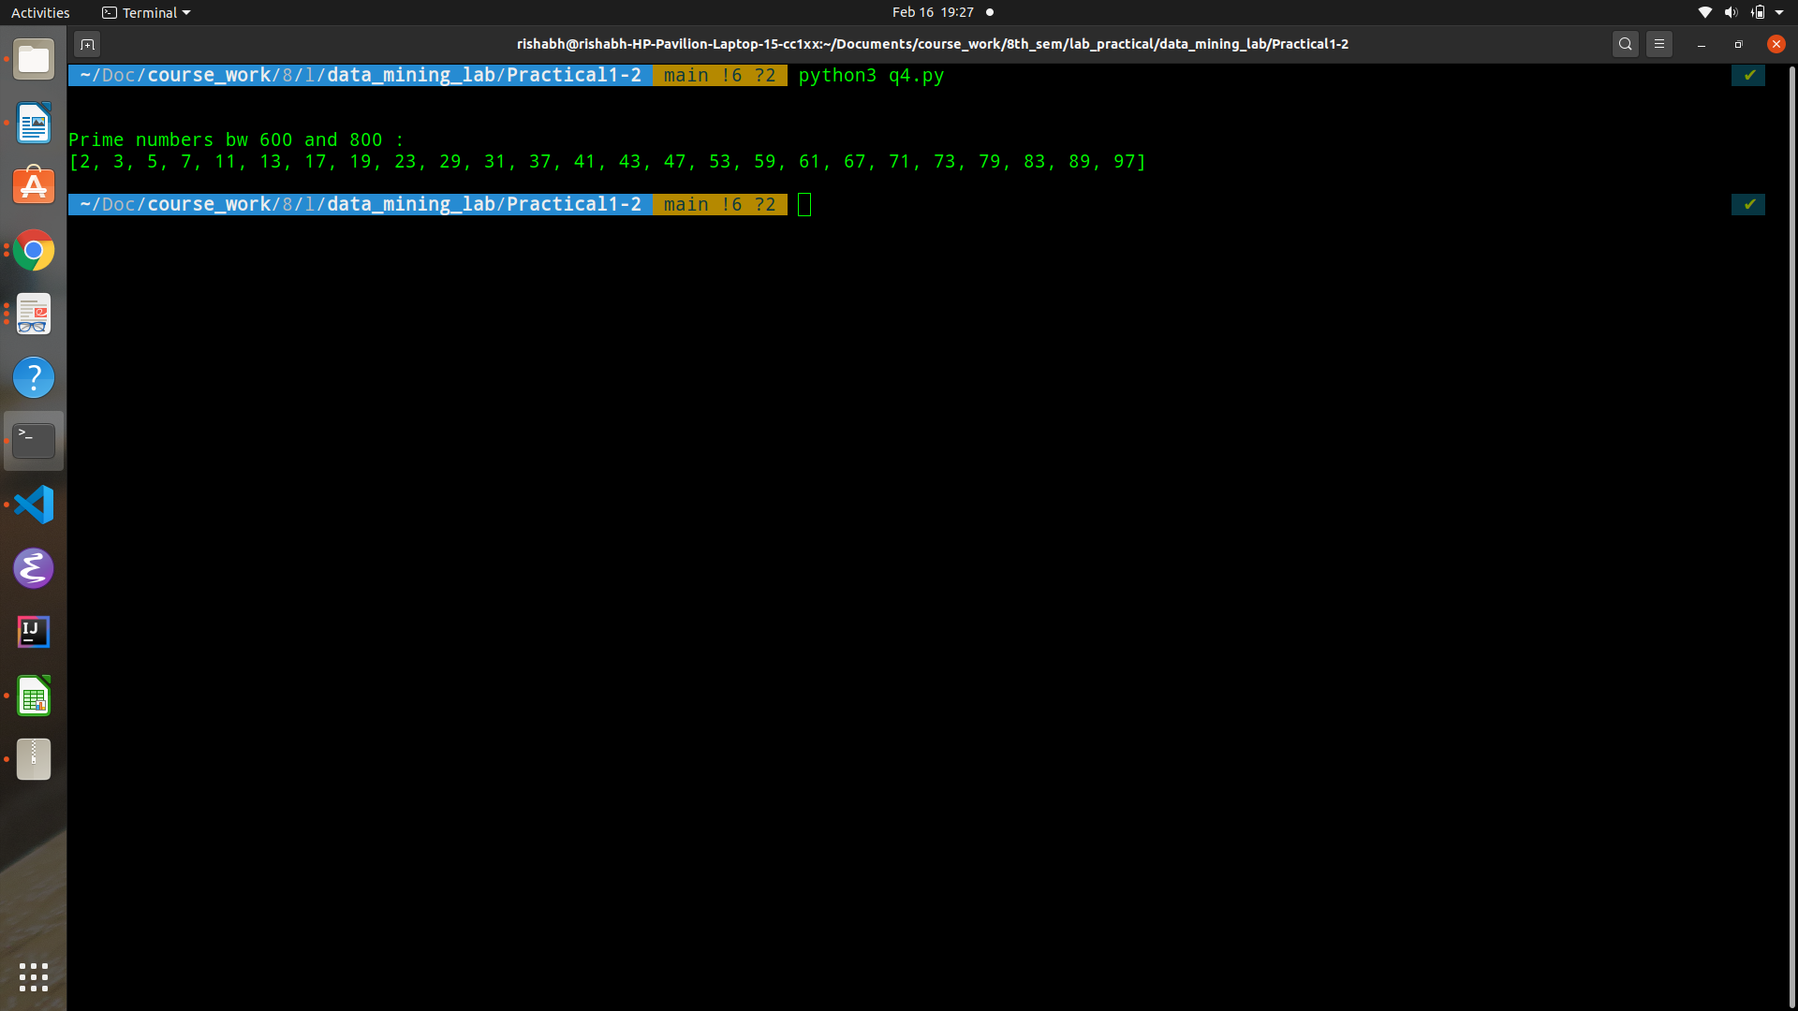

iii. WAP to print all numbers between 100 and 1000 that are divisible by 7 and 9.

Code:

|  |
| --- |
| nums_divisible_by_7_or_9 = [n for n in range(100, 1001) if(n % 63 == 0)]  print(nums_divisible_by_7_or_9) |

Output:

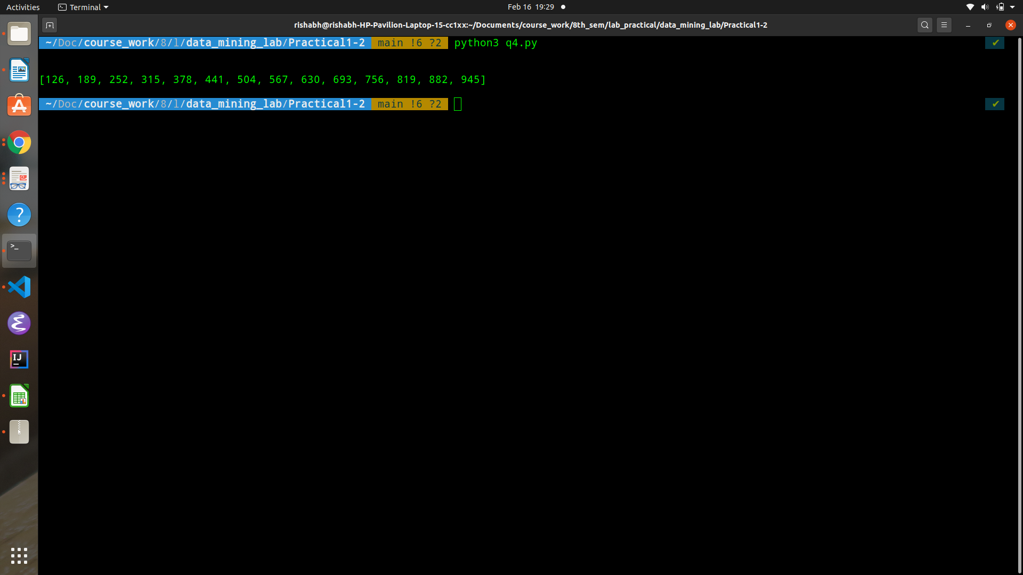

Q5. WAP to create two lists of 10 random numbers between 10 and 30;

|  |
| --- |
| import random  range_start, range_end = 10, 31  numbers = [n for n in range(range_start, range_end)]  list_one = [random.choice(numbers) for i in range(10)]  list_two = [random.choice(numbers) for i in range(10)] |

Find

i. Common numbers in the two lists

Code:

|  |
| --- |
| common_elements = [n for n in list_one if n in list_two]  print(common_elements) |

Output:

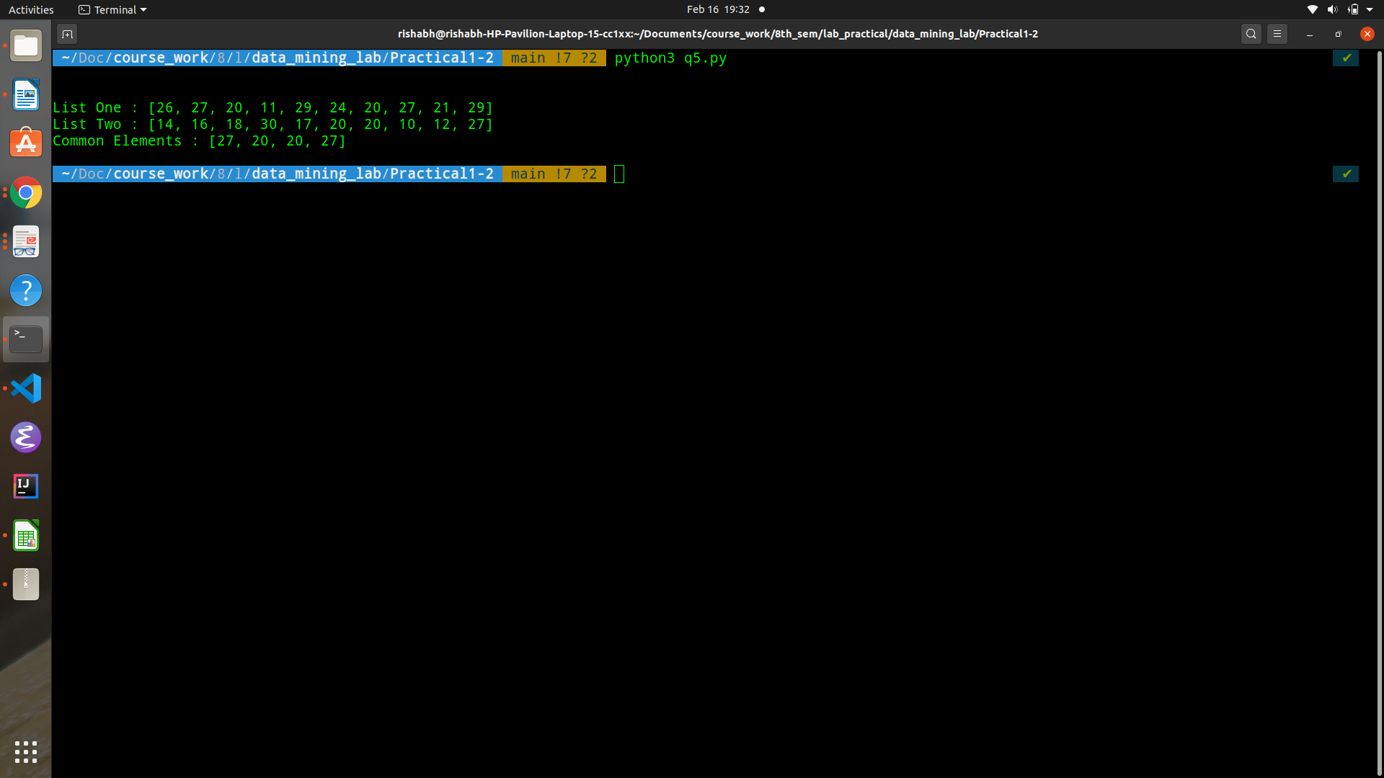

ii. Unique numbers in both the list

Code:

|  |
| --- |
| unique_elements_list_one = [ n for n in list_one if n not in list_two]  unique_elements_list_two = [ n for n in list_two if n not in list_one]  unique_elements = unique_elements_list_one + unique_elements_list_two |

Output:

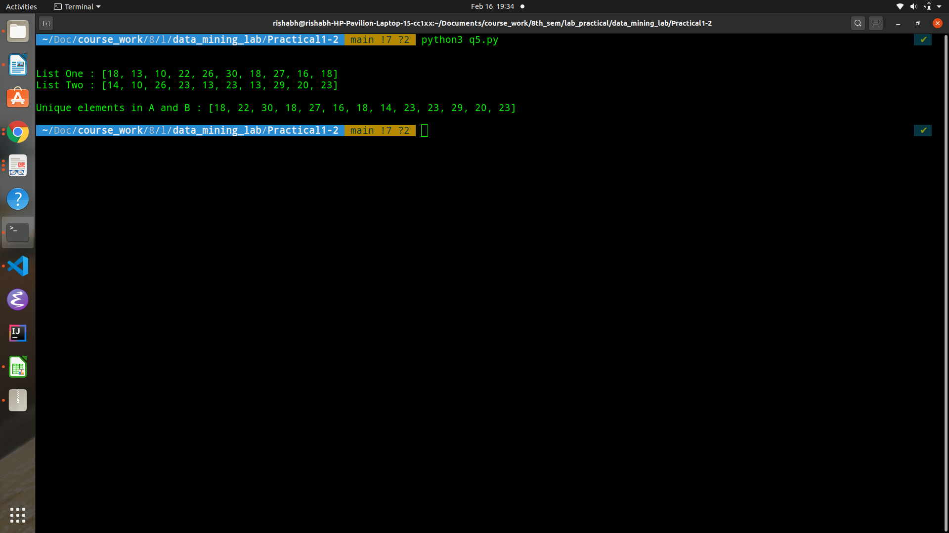

iii. Minimum in both the list

Code:

|  |
| --- |
| min_list_one = min(list_one)  min_list_two = min(list_two)  min_value_across_both_lists = min(min_list_one, min_list_two) |

Output:

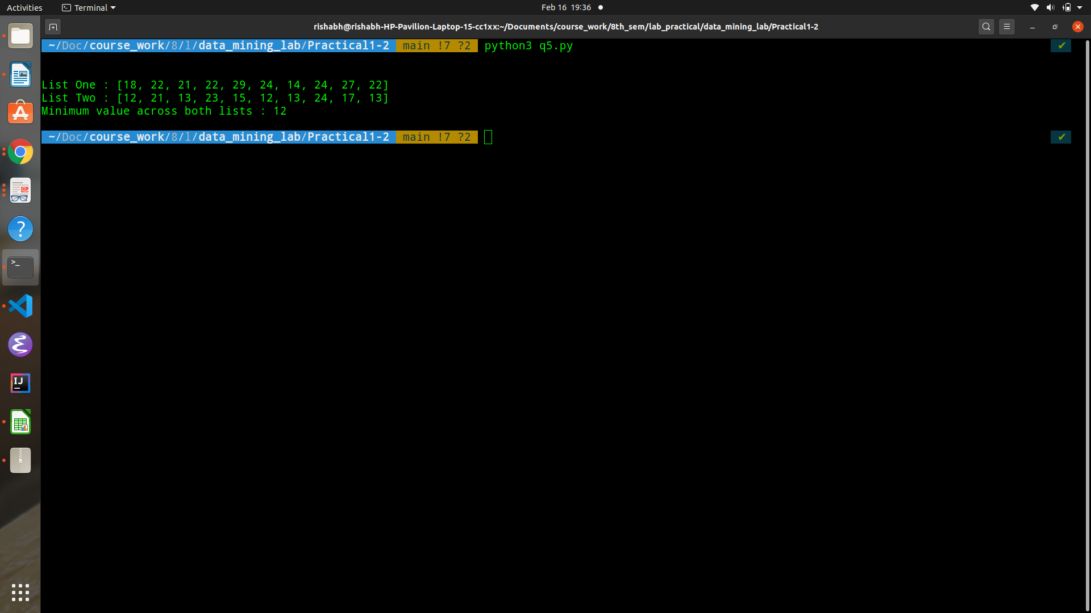

iv. Maximum in both the list

Code:

|  |
| --- |
| max_list_one = max(list_one)  max_list_two = max(list_two)  max_value_across_both_lists = max(max_list_one, max_list_two) |

Output:

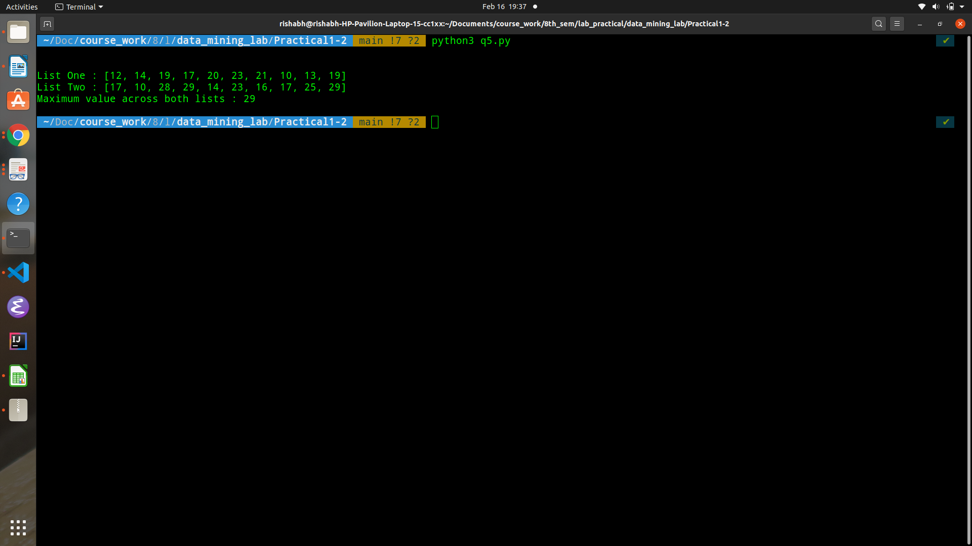

v. Sum of both the lists

Code:

|  |
| --- |
| sum_list_one = sum(list_one)  sum_list_two = sum(list_two)  total_sum = sum_list_one + sum_list_two |

Output:

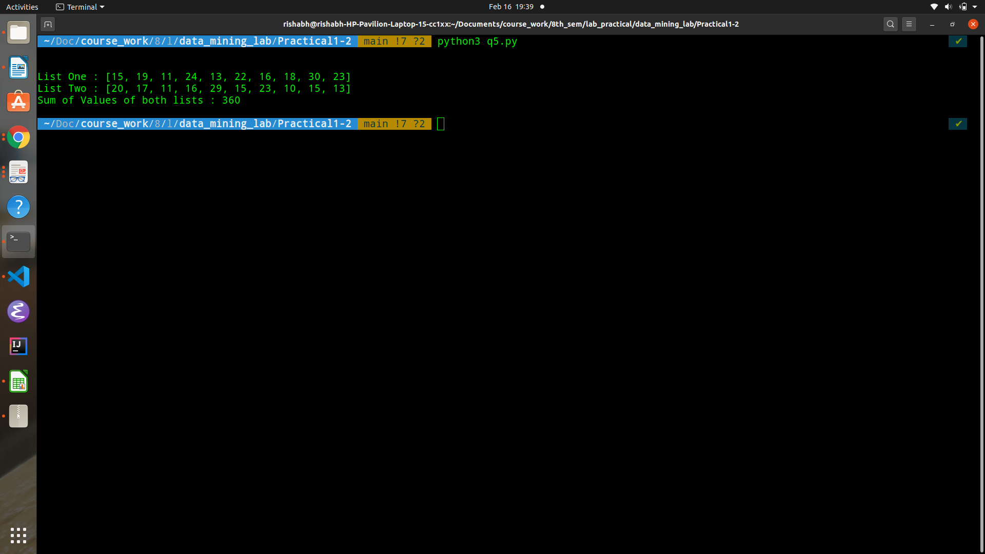

Q6. WAP to create a list of 100 random numbers between 100 and 900.

|  |
| --- |
| input = [ n for n in range(100, 901) ] |

Count and print the:

i. All odd numbers

Code:

|  |
| --- |
| def is_odd(element):  return (element % 2 != 0)  odd_numbers = [number for number in input if is_odd(number)]  sum_odd = sum(odd_numbers)  print(odd_numbers)  print(sum_odd) |

Output:

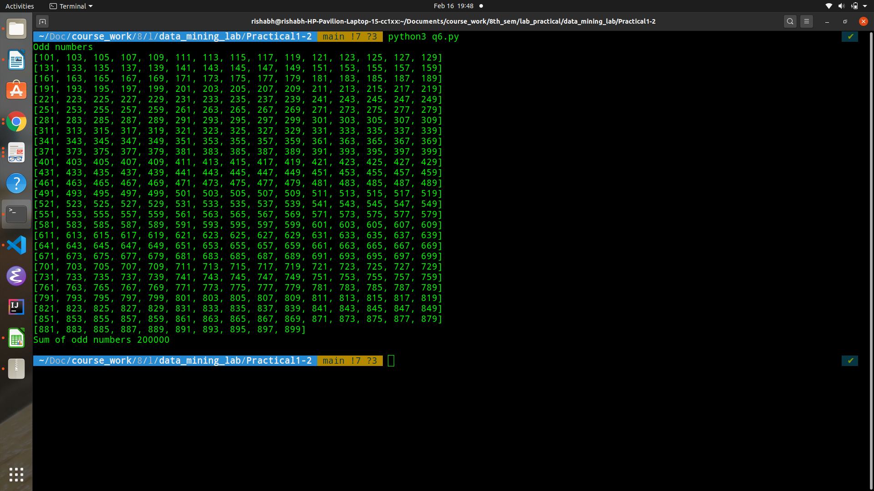

ii. All even numbers

Code:

|  |
| --- |
| def is_even(element):  return (element % 2 == 0)  even_numbers = [number for number in input if is_even(number)]  sum_even = sum(even_numbers)  print(even_numbers)  print(sum_even) |

Output:

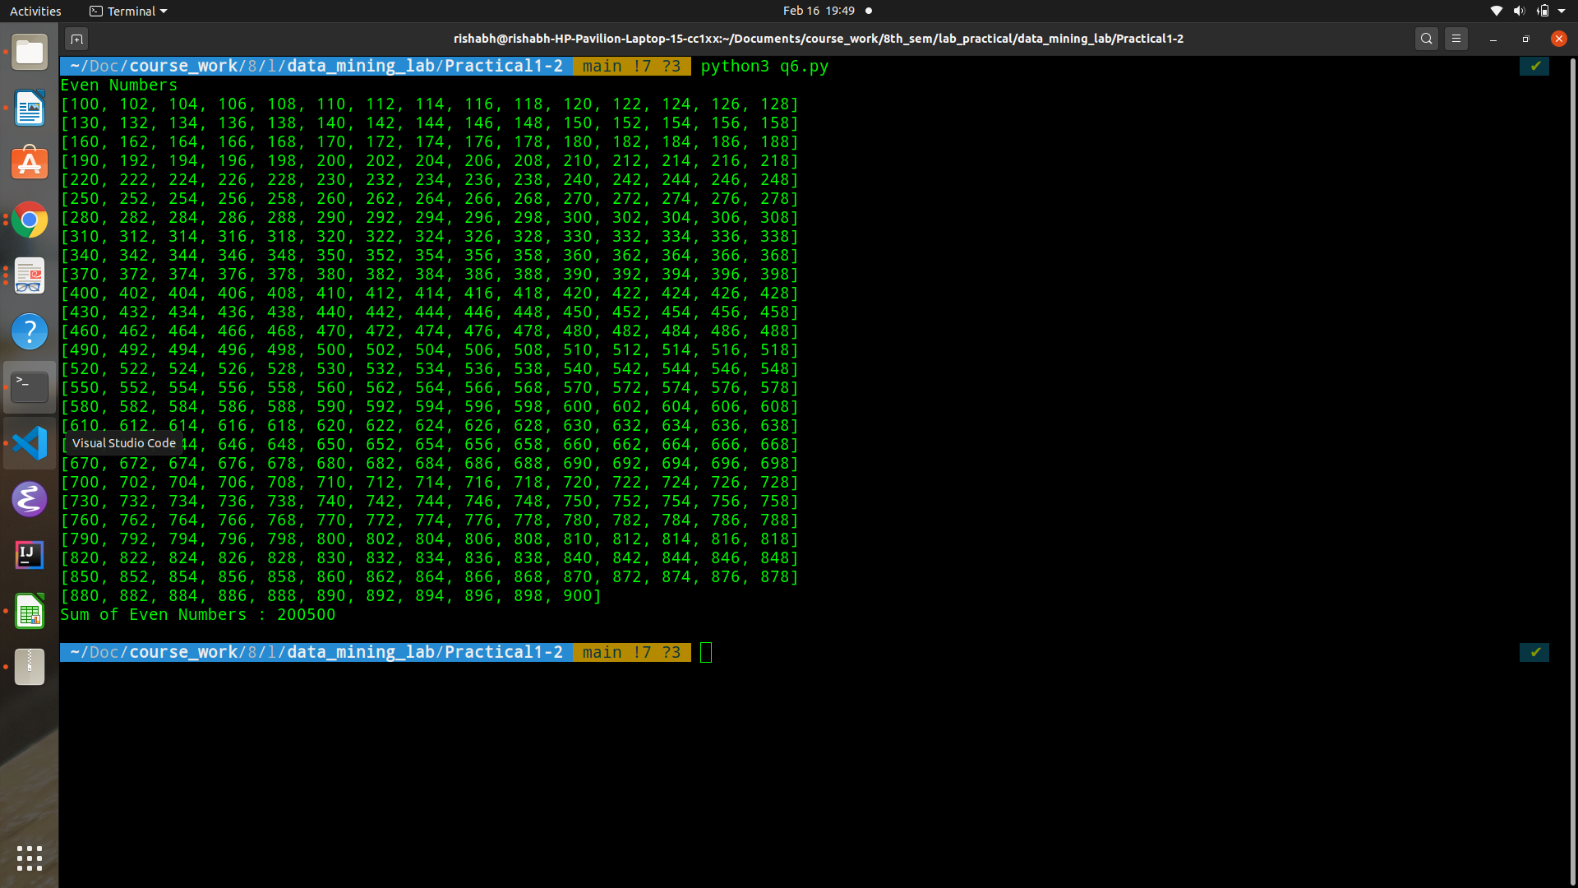

iii. All prime numbers

Code:

|  |
| --- |
| def is_prime(element):    if element < 2:  return False    i = 2  while i * i <= element:    if element % i == 0:  return False  i += 1    return True  prime_numbers = [number for number in input if is_prime(number)]  sum_prime = sum(prime_numbers)  print(prime_numbers)  print(sum_prime) |

Output:

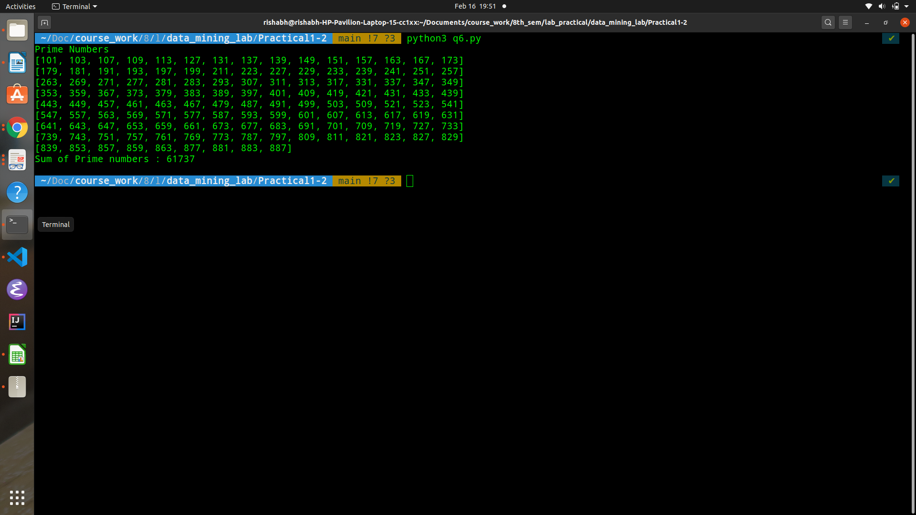

Q7. D is a dictionary defined as D={1:"One",2:"Two",3:"Three",4:"Four", 5:"Five"}.

WAP to read all the keys and values from dictionary and write to the file in the given below

format.

Key1, Value1

Key2, Value2

Key3, Value3Q8. L is a list defined as L={"One","Two","Three","Four","Five"}.

WAP to count the length of reach element from a list and write to the file in the given below

format:

One, 3

Two, 3

Four, 4

Code:

|  |
| --- |
| D = {  1 : "One",  2 : "Two",  3 : "Three",  4 : "Four",  5 : "Five"  }  with open('q7_output.txt', 'r+') as output_file:  for key, value in D.items():  output_file.write(f'{value}, {len(value)}\n') |

Output:

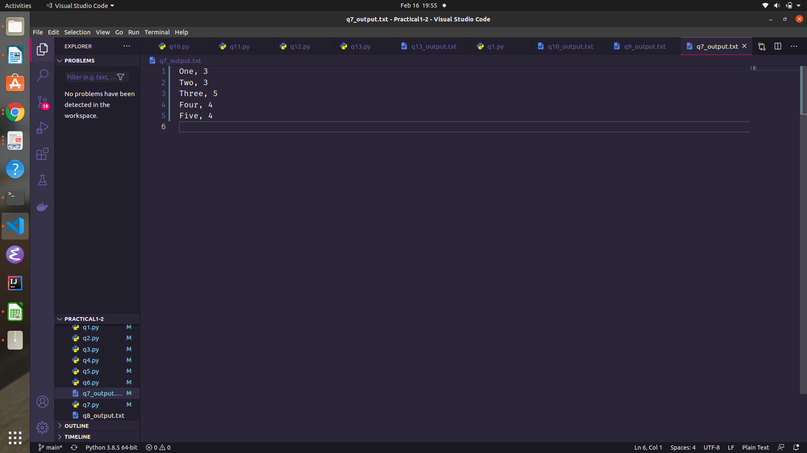

Q8. L is a list defined as L={"One","Two","Three","Four","Five"}.

WAP to count the length of reach element from a list and write to the file in the given below

format:

One, 3

Two, 3

Four, 4

Code:

|  |
| --- |
| L = ["One", "Two", "Three", "Four", "Five"]  with open("q8_output.txt", 'r+') as output_file:    for item in L:  output_file.write(f'{item}, {len(item)}\n') |

Output:



Q9. Write to the file 100 random strings whose length between 10 and 15.

Code:

|  |
| --- |
| # generate 100 random strings len in range(10, 15) -> file  import string  import random  range_start, range_end = 10, 16  n_strings = 100  letters = string.ascii_letters  with open('q9_output.txt', 'r+') as output_file:  for i_string in range(n_strings):  # generate a string  len_random_str = random.randint(range_start, range_end)  random_str = ''.join(random.choice(letters) for i in range(len_random_str))  # write string to file  output_file.write(f'{random_str}\n') |

Output:

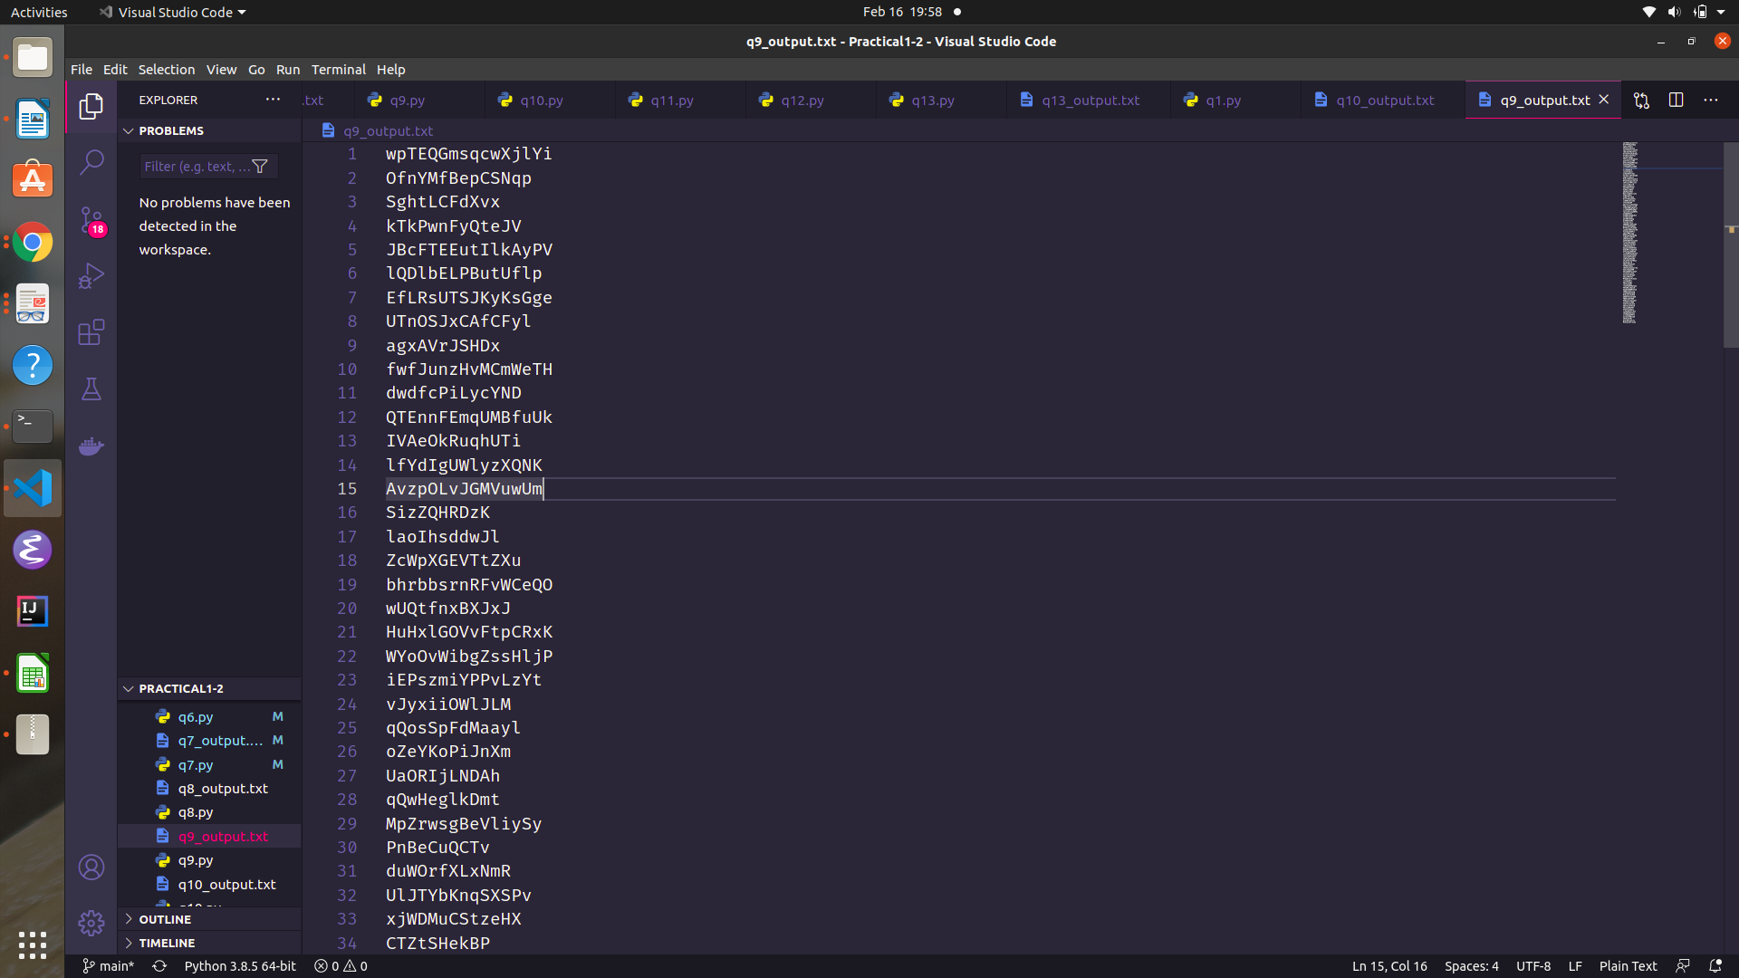

Q10. Write to the file all prime numbers between 600 and 800.

Code:

|  |
| --- |
| range_start, range_end = 1, 100  from q6 import is_prime  with open('q10_output.txt', 'r+') as output_file:    for number in range(range_start, range_end):  if is_prime(number):  output_file.write(f'{number}\n') |

Output:

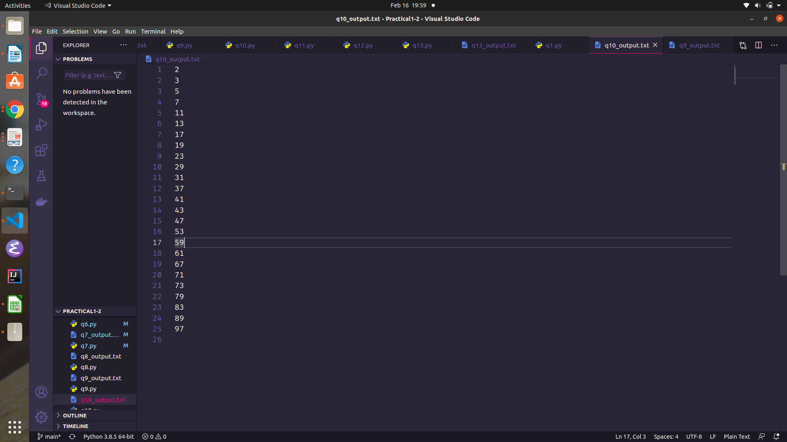

Q11. WAP to calculate the time taken by a program.

Code:

|  |
| --- |
| # time taken by a program  import time  def do_stuff():  for i in range(100000):  i = i + 3  start_time = time.time()  do_stuff()  processing_time = (time.time() - start_time)  print(processing_time) |

Output:

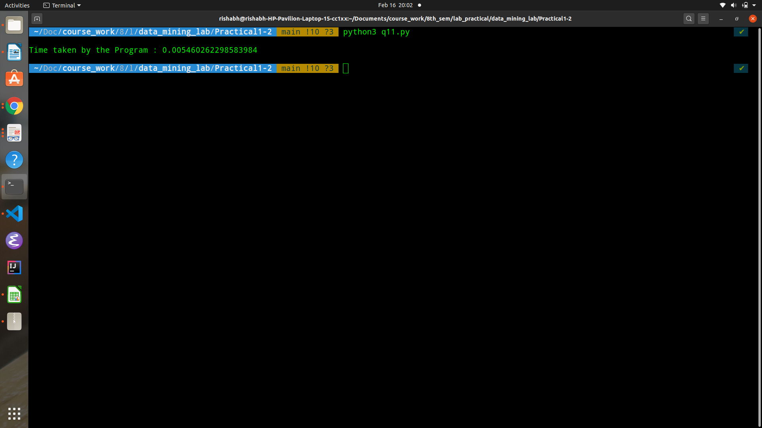

Q12. WAP to create a dictionary of student marks in five subjects and you have to find the

student having maximum and minimum average marks.

Code:

|  |
| --- |
| class Student:  def __init__(self, name):  self.marks = []  self.name = name  def __str__(self) -> str:  if len(self.marks) == 0:  average_marks = 0  else:  average_marks = sum(self.marks) / len(self.marks)  return f'{self.name}\t:\t{average_marks}\n'  def add_marks(self, marks : int):  self.marks.append(marks)  def get_average_marks(self):  return sum(self.marks) / len(self.marks)  def assign_marks(subject_marks, students):  for subj_marks in subject_marks:  for idx, marks in enumerate(subj_marks):  students[idx].add_marks(marks)  def main():  # create 5 students  s1 = Student('student 1')  s2 = Student('student 2')  s3 = Student('student 3')  s4 = Student('student 4')  s5 = Student('student 5')    subj_one_marks = [10, 32, 23, 11, 32]  subj_two_marks = [14, 52, 63, 17, 35]  subj_three_marks = [6, 72, 43, 31, 42]  subj_four_marks = [16, 12, 13, 51, 34]  subj_five_marks = [8, 34, 15, 14, 36]  students = [s1, s2, s3, s4, s5]  subject_marks = [subj_one_marks, subj_two_marks, subj_three_marks, subj_four_marks, subj_five_marks]  assign_marks(subject_marks, students)  # get max and min average score  average_scores = [x.get_average_marks() for x in students]  min_marks_loc = average_scores.index(min(average_scores))  max_marks_loc =average_scores.index(max(average_scores))    print('Student Name\tAverage Marks')  for student in students:  print(student)  print(f"Max average achieved by student: {students[max_marks_loc]}")  print(f"Min average achieved by student: {students[min_marks_loc]}")  main() |

Output:

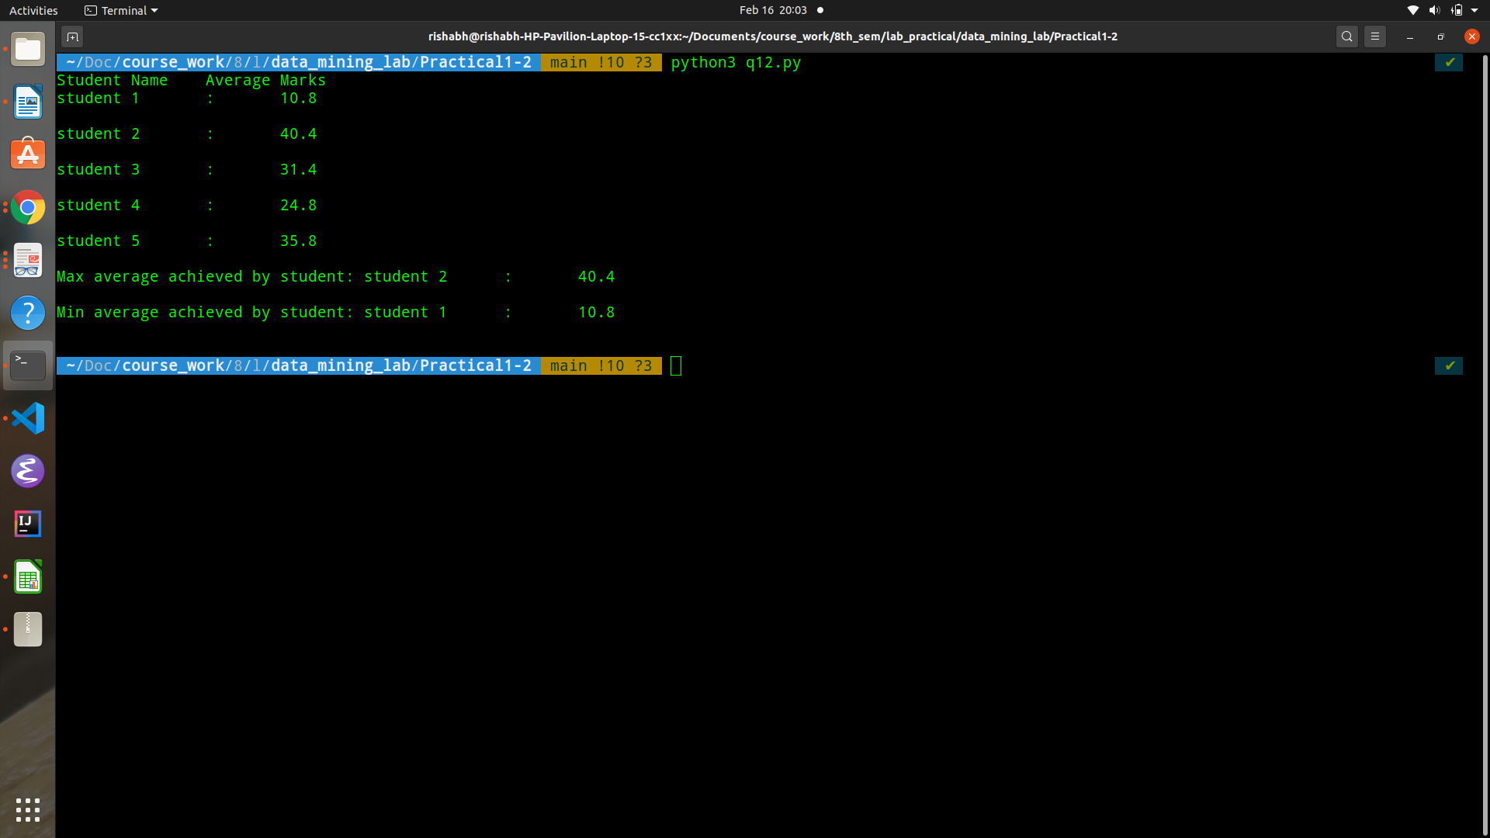

Q13. WAP to sort the following number of elements in a list and calculate time taken. Number of elements in list Time Taken to sort

5k T1

10k T2

15k T3

20k T4

25k T5

Code:

|  |
| --- |
| import random  import time  def generate_random_list(size):  return [random.randint(1, 100000) for i in range(size)]  def write_result(list_sizes, exec_times):  with open('q13_output.txt', 'r+') as output_file:  output_file.write('List Size\tExecution Time(ns)\n')  for index, size in enumerate(list_sizes):  output_file.write(f'{size}\t{exec_times[index]}\n')  def main():  list_sizes = [5000, 10000, 15000, 20000, 25000]  exec_times = []  for size in list_sizes:  # generate a list of size  random_list = generate_random_list(size)  start_time = time.time()  random_list.sort()  exec_times.append((time.time() - start_time) * 1000)    print(exec_times)  write_result(list_sizes, exec_times)  main() |

Output:

